Science 8
Unit B
Lesson 11
Self-Check Quiz

Answer all 5 questions in the spaces provided. Think carefully before typing your answers. If you need help, return to the lesson in the online course. Save your quiz when you are done.

Leave your answers in blue; it will be easier for you and your teacher to see them later.

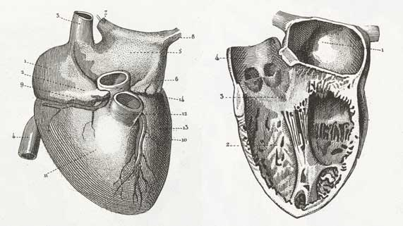
Question 1

Explain why the left ventricle of the heart is surrounded by a thick layer of muscle.

Type your answer here.

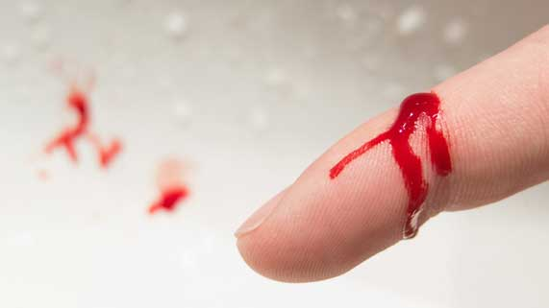
Question 2

A boy accidentally cut his finger with a knife.

Describe the functions of white blood cells and platelets at the site of the injury.

Type your answer here.

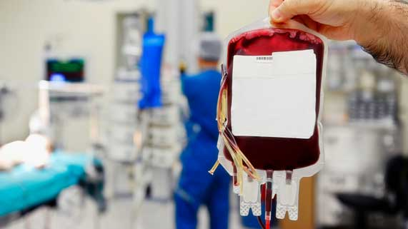
Question 3

Explain two reasons why donated blood is tested before it is used in blood transfusions.

Type your answer here.

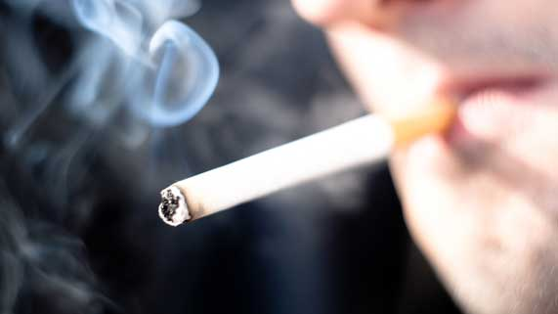
Question 4

Nicotine in tobacco smoke causes the muscles of blood vessels to tighten and become narrower.

How does nicotine affect blood pressure?

Type your answer here.

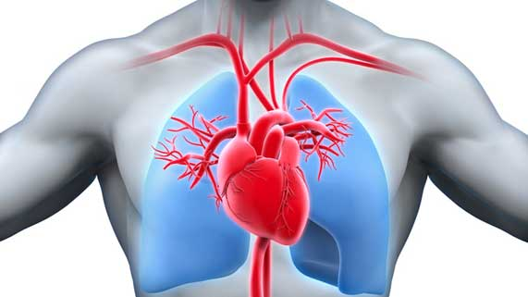
Question 5

Why does blood need to make a trip from the heart to the lungs and back, before blood is pumped out to the entire body?

Type your answer here.

Congratulations! You have completed this self-check quiz.

Now it's time to carefully compare your answers to the suggested answers in the online course. When comparing, you should feel free to make changes to your answers or make extra notes.

Don't forget to save the quiz whenever you make changes.

Keep this quiz for study purposes. If you want more feedback, share it with your teacher.

