Science 8
Unit B
Lesson 12
Self-Check Quiz

Answer all 5 questions in the spaces provided. Think carefully before typing your answers. If you need help, return to the lesson in the online course. Save your quiz when you are done.

Leave your answers in blue; it will be easier for you and your teacher to see them later.


Question 1

Why is it important to carry a water bottle with you on a hot day?

Type your answer here.

Question 2

Explain how a kidney stone blocking a ureter stops the urinary system from functioning properly.

Type your answer here.

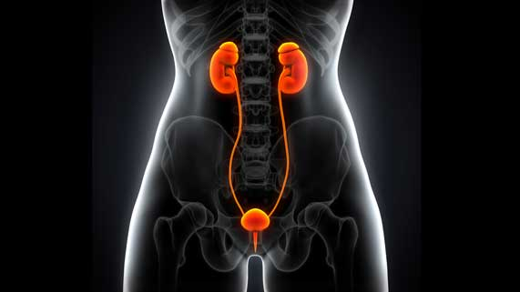
Question 3

What is the function of the urinary bladder and why is it important?

Type your answer here.

Question 4

Explain why a symptom of dehydration is a lack of urination.

Type your answer here.

Question 5

Explain why kidney failure can cause a person to die if they are not treated with dialysis or a kidney transplant.

Type your answer here.

Congratulations! You have completed this self-check quiz.

Now it's time to carefully compare your answers to the suggested answers in the online course. When comparing, you should feel free to make changes to your answers or make extra notes.

Don't forget to save the quiz whenever you make changes.

Keep this quiz for study purposes. If you want more feedback, share it with your teacher.

