Science 8
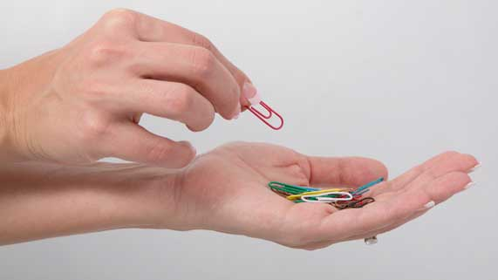
Unit B Lesson 13
Try It!
Two-Point Touch
Try this experiment on a family member or friend to test the touch sensitivity of different body parts.
Materials:
- 2 metal paper clips
- Ruler with millimetre measurements

Instructions:
- Bend the 2 paper clips so that they are straight.
- Have your partner sit down with their eyes closed. Your partner’s eyes need to remain closed for the entire experiment.
- Use the ruler to hold the paper clips 1 mm apart along the back of your partner’s hand.
- Gently touch the person’s hand with the two paper clips at the same time, and ask your partner to tell you whether they feel one point or two.
- If your partner feels two points, record the distance of 1 mm on the observations table. If your partner feels one point, increase the distance between the paper clips to 2 mm and repeat step 4. Continue until you reach a distance where your partner feels two points, and record this distance on the observations table.
- Repeat steps 2-5 for your partner’s fingertip, palm, forearm, upper arm, and upper back.

Observation Table:
Body Part | Distance to Feel Two Points (mm)
Back of hand
Fingertip
Palm of hand
Forearm
Upper arm
Upper back

Questions:
Think about the following questions very carefully. Then, type or write your answers. When you have your answers, return to the online course and click the questions for feedback.

- Which body parts were the most sensitive to touch? How do you know?

- Which body parts were the least sensitive to touch? How do you know?

- Why are certain body parts more sensitive to touch than others?

