Science 8
Unit B
Lesson 13
Self-Check Quiz

Answer all 5 questions in the spaces provided. Think carefully before typing your answers. If you need help, return to the lesson in the online course. Save your quiz when you are done.

Leave your answers in blue; it will be easier for you and your teacher to see them later.

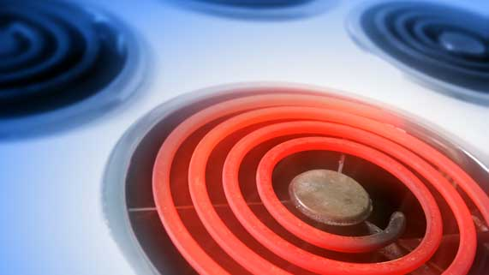
Question 1

If you touch a stove burner, your reflexes make you pull your hand away quickly without thinking about it.

Why do reflexes send messages to the spinal cord and back, instead of sending messages to the brain?

Type your answer here.

Question 2

What is an example of a body function that involves the somatic nervous system? What is an example of a body function that involves the autonomic nervous system?

Type your answer here.

Question 3

A man breaks his spine, halfway down his back, damaging his spinal cord. What resulting medical condition would you expect to see in this man?

Type your answer here.

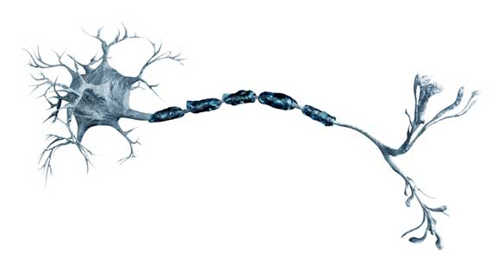
Question 4

Nerve cells extend into a long fiber called an axon.

Why do nerve cells have axons in their structures?

Type your answer here.

Question 5

Why are the brain and spinal cord protected with bone?

Type your answer here.

Congratulations! You have completed this self-check quiz.

Now it's time to carefully compare your answers to the suggested answers in the online course. When comparing, you should feel free to make changes to your answers or make extra notes.

Don't forget to save the quiz whenever you make changes.

Keep this quiz for study purposes. If you want more feedback, share it with your teacher.

