Science 8
Unit B
Section 3
Self-Check Quiz

Answer all 5 questions in the spaces provided. Think carefully before typing your answers. If you need help, return to the lesson in the online course. Save your quiz when you are done.

Leave your answers in blue; it will be easier for you and your teacher to see them later.

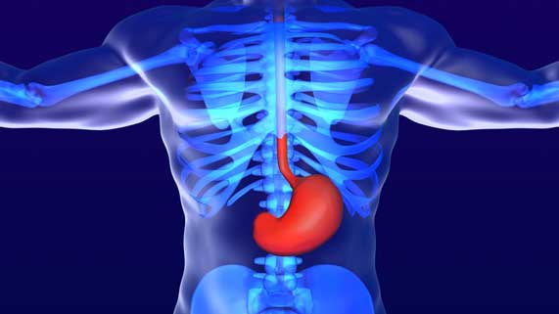
Question 1

Explain the two types of digestion that occur in the stomach.

Type your answer here.

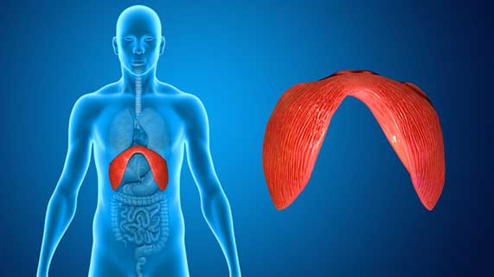
Question 2

Why is the diaphragm necessary for breathing?

Type your answer here.

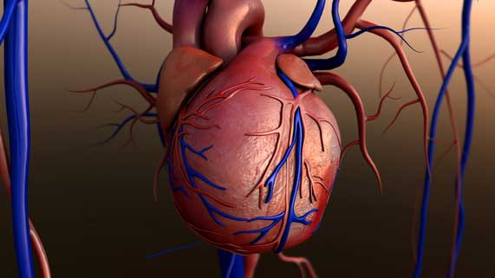
Question 3

Why is the heart surrounded with many blood vessels that carry oxygen and nutrients to heart muscle cells?

Type your answer here.

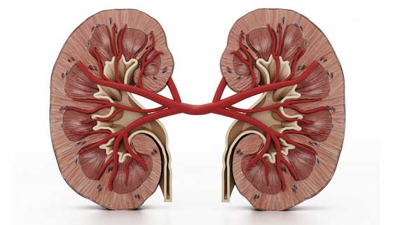
Question 4

Could your body function without kidneys? Explain.

Type your answer here.

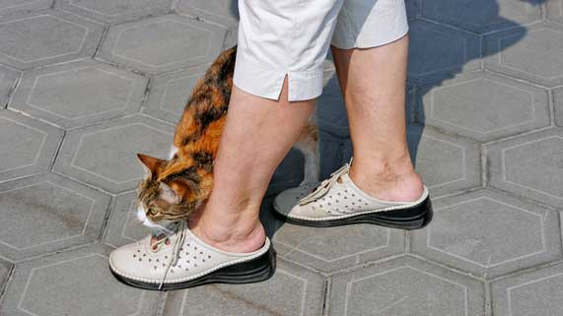
Question 5

A cat rubs against a woman’s legs.

Describe the pathway in the nervous system that sends a message to the woman to look down at the cat by her legs.

Type your answer here.

Congratulations! You have completed this self-check quiz.

Now it's time to carefully compare your answers to the suggested answers in the online course. When comparing, you should feel free to make changes to your answers or make extra notes.

Don't forget to save the quiz whenever you make changes.

Keep this quiz for study purposes. If you want more feedback, share it with your teacher.

