Science 8
Unit B
Lesson 15
Self-Check Quiz

Answer all 5 questions in the spaces provided. Think carefully before typing your answers. If you need help, return to the lesson in the online course. Save your quiz when you are done.

Leave your answers in blue; it will be easier for you and your teacher to see them later.

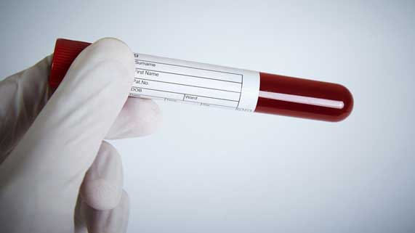
Question 1

A man has a blood test done. His doctor says that cholesterol levels in his arteries are too high, putting him at risk for a heart attack or stroke.

What lifestyle changes could the man make to improve his health?

Type your answer here.


Question 2

Why does washing your hands every single time after using the toilet prevent infectious diseases from spreading?

Type your answer here.

Question 3

Explain why people who live in cities have a greater risk of getting respiratory illnesses like asthma, compared to people who live in rural areas.

Type your answer here.


Question 4

Ebola healthcare workers have to wear protective clothing covering all of their skin. They are sprayed with a disinfectant liquid after treating patients.

Explain why ebola healthcare workers need to take these protective measures.

Type your answer here.

Question 5

In the 1300’s, a bacteria-caused disease called the Black Death took seven years to spread widely across Europe. Today, contagious diseases spread around the world much faster. Why do diseases spread more quickly today than in the past?

Type your answer here.

Congratulations! You have completed this self-check quiz.

Now it's time to carefully compare your answers to the suggested answers in the online course. When comparing, you should feel free to make changes to your answers or make extra notes.

Don't forget to save the quiz whenever you make changes.

Keep this quiz for study purposes. If you want more feedback, share it with your teacher.

