Science 8
Unit C
Lesson 2
Self-Check Quiz

Answer all 5 questions in the spaces provided. Think carefully before typing your answers. If you need help, return to the lesson in the online course. Save your quiz when you are done.

Leave your answers in blue; it will be easier for you and your teacher to see them later.

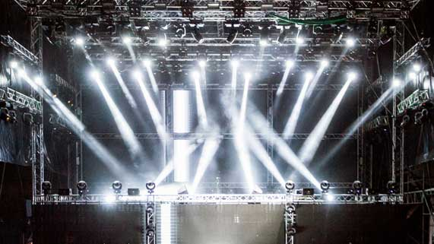
Question 1

Theatre stages are lit with spotlights. What property of light is shown most clearly by theatre lights?

Type your answer here.


Question 2

Why can you see a reflection of trees on a still pond, even though water is a clear liquid, and not solid like a mirror?

Type your answer here.

Question 3

Why does a black shirt make you feel very hot on a sunny summer day?

Type your answer here.

Question 4

Why do white surfaces feel cool on sunny days?

Type your answer here.

Question 5

Why is it very dangerous to shine a laser pointer into someone’s eyes?

Type your answer here.

Congratulations! You have completed this self-check quiz.

Now it's time to carefully compare your answers to the suggested answers in the online course. When comparing, you should feel free to make changes to your answers or make extra notes.

Don't forget to save the quiz whenever you make changes.

Keep this quiz for study purposes. If you want more feedback, share it with your teacher.

