Science 8
Unit C
Section 1
Self-Check Quiz

Answer all 5 questions in the spaces provided. Think carefully before typing your answers. If you need help, return to the lesson in the online course. Save your quiz when you are done.

Leave your answers in blue; it will be easier for you and your teacher to see them later.

Question 1

Explain one useful technology or optical device that uses light to operate. How has this technology helped humans in everyday life?

Type your answer here.

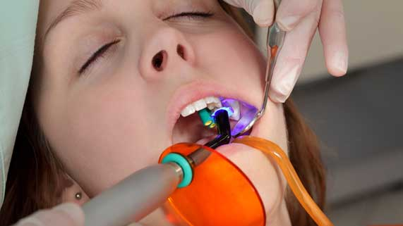
Question 2

Some dentists use lasers to treat cavities. Dental lasers heat up decaying tissue in a tooth. The heat expands the decaying tissue, which pushes it out of the cavity before the dentist applies a filling.

What property of light does dental laser technology best demonstrate?

Type your answer here.

Question 3

Light strikes the inside of a fibre optic cable at a 60 degree angle. Explain what angle the light will reflect at.

Type your answer here.

Question 4

The nearest star to Earth is Alpha Centauri, which is about 40 trillion kilometers away. Explain why light from Alpha Centauri takes 4.3 years (about 133 000 000 seconds) to travel to Earth.

Type your answer here.

Question 5

How do lenses, like the ones found in telescopes and microscopes, help to magnify images?

Type your answer here.

Congratulations! You have completed this self-check quiz.

Now it's time to carefully compare your answers to the suggested answers in the online course. When comparing, you should feel free to make changes to your answers or make extra notes.

Don't forget to save the quiz whenever you make changes.

Keep this quiz for study purposes. If you want more feedback, share it with your teacher.

