Science 8
Unit C, Section 1
Project
Light Technology Story

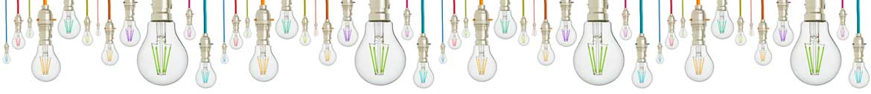
You are required to submit the following project to your teacher for marks. Very carefully, read the project and how to do it. Be sure to read the requirements and rubric, they explain the expectations for this project and how it will be marked.

Situation

Modern humans depend on light for many technologies we use in our everyday lives. Without understanding the properties of light, inventors could not develop new and useful light technologies. Scientific inventions usually have interesting stories of how they came to be. What inspired the inventor? What was the inventor curious about?

Project Task

Research a light technology and its invention. Tell the story of how this light technology was invented, describe the properties of light the technology depends on, and explain how we depend on the light technology every day.

Before you begin your research and story, ask yourself these questions:

- What modern technologies use light?
- How can I find out about other light technologies that I don’t know about?

Method:

- Choose a technology that uses light. You may choose from a technology introduced to you in Section C1, or choose one of your own.

- Check with your teacher before you start researching your light technology, to make sure it is appropriate for this task.

- Research your chosen light technology. Sources of information include the following:

- Section C1 lessons
- Reference books
- News articles in newspapers, magazines, or other publications
- Websites
- YouTube videos
- Interviews with adults who work with light technology

- Use the document you downloaded, or construct your own table like the one below to record collected information. The categories that you must research are indicated on the table.

The table must contain information summarized in your own words. Beside each piece of supporting information, list the source of the information. For example, insert the URL of any websites, book titles and authors, newspaper names and dates of publication or names of people interviewed as your sources.

You must submit the table with your story (see step 4).

Category | Information | Source of Information
Description of the light technology
- What does it look like?
- What useful task does it do?
- Include a photo or drawing.
Description of the light technology’s invention
- When was it invented?
- Who invented it?
- How did the inventor come up with the idea or develop the light technology?
Explanation of how light’s properties work in the technology
- What properties of light does the technology rely on?
- How does light make the technology work?
Explanation of how the light technology has changed society
- How did we solve the need or problem before the light technology?
- How does the light technology make solving the problem better?
- How did the world change after the light technology was invented?

- Create and communicate a story to explain the light technology and how it was invented. Here are some ideas from which you can choose:

- Write and/or illustrate a children’s storybook
- Write diary entries from the inventor’s perspective
- Draw a wall mural of the story
- Draw a comic strip of the story
- Write and/or video a dramatic play
- Write and/or record a radio show or podcast
- Use other creative ideas, but check with your teacher first
Rubric

A rubric explains how your work will be evaluated. It explains clearly all the aspects you must include in your assessment. Read it very carefully before you start your work.

Light Technology Story
28 marks

CRITERIA | PERFORMANCE
CRITERIA |  | NOT OK | OK | GOOD | EXCELLENT
CRITERIA | Not Submitted  0 marks | Does not  meet criteria  1 mark | Minimally  meets criteria  2 marks | Fully  meets criteria  3 marks | Exceeds  criteria  4 marks
Research table completed | Not  Submitted | Research table is not completed; it lacks details and sources of information. | Research table is somewhat completed; some details and sources of information are confusing or lacking. | Research table and sources of information are completed; some supporting details and examples are provided. | Research table and sources of information are completed; several supporting details and examples are provided.
Description of light technology | Not  Submitted | No description of light technology. | Description of light technology is too brief and lacks detail. | Full basic description of light technology provided. | Full description of light technology provided with great detail.
Description of the light technology’s invention | Not  Submitted | No description of light technology’s invention. | Description of light technology’s invention is too brief and lacks detail. | Full basic description of light technology’s invention and inventor provided. | Full description of light technology’s invention and inventor provided with great detail.
Explanation of how light’s properties work in the technology | Not  Submitted | No explanation of how light’s properties work in the technology. | Explanation of how light’s properties work in the technology is too brief and lacks detail. | Full basic explanation of light’s properties work in the technology. | Full detailed explanation of how light’s properties work in the technology.
Explanation of how the light technology changed society | Not  Submitted | No explanation of how the light technology changed society. | Explanation of how the light technology changed society is too brief and lacks detail. | Full basic explanation of how the light technology changed society. | Full detailed explanation of how the light technology changed society.
Communication | Not  Submitted | Story not communicated clearly; details lacking. | Story partly communicated; some details lacking or confusing. | Story communicated, but descriptions brief. | Story communicated with great detail and clarity.
Creativity | Not  Submitted | Story is very simple and lacks imagination. | Story is very simple but shows some imagination. | Story has a few details and shows some imagination. | Story has many details and shows a great deal of imagination.


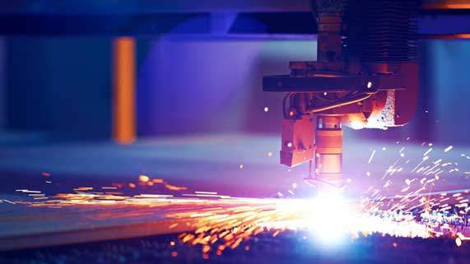

Submitting Your Work

- If you print your work and/or do pencil drawing(s) on another piece of paper, you must scan your work to submit it.
- If you have prepared any other electronic images or documents for this project, you must submit them.
- If you have used an Internet location where your work is located, you must submit the URL so your teacher can view your work.

When you are ready to submit your completed project, return to the proper page in the online course and follow the instructions at the bottom of the page for submitting your work.

Note that when you submit anything to your teacher, PLEASE INCLUDE YOUR NAME IN THE DOCUMENT TITLE. For example, you might title it something like this:


UnitC_Section1_Project_Jenny_Smith.doc

