
Science 8
Unit C Section 2
Try It!
Shadows
Try this simple activity to observe how shadows form.
Materials:
- Desk lamp
- Wall
- Meter stick or measuring tape
- Pencil
Instructions:
- Place the lamp at one end of a table.
- If possible, remove the lampshade from the desk lamp. Turn on the lamp.
- Hold the pencil upright below the lamp. The top of the pencil should be 10 cm below the top of the lamp.
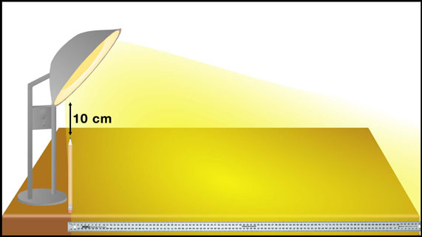
- Measure and record the length of the pencil’s shadow in the observations table.
- Have a friend or parent hold a meter stick or measuring tape that touches the top of the lamp and the top of the pencil. What do you observe about where the meter stick extends to touch the table?

- Repeat steps 3 to 5. Keep the pencil 10 cm below the light, but move it 20 cm to the side of the light to make your observations.
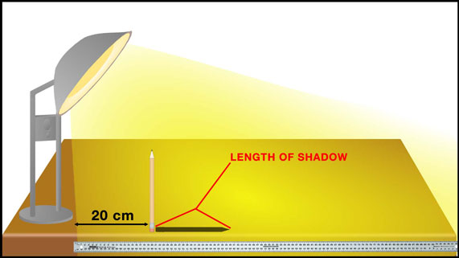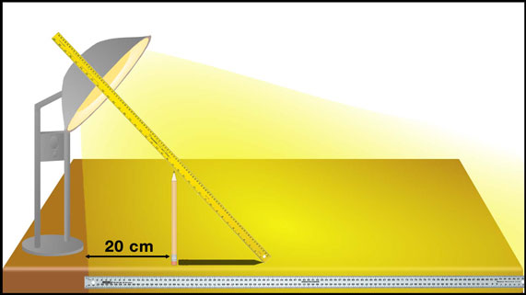
- Repeat steps 3 to 5 for the pencil at distances of 40, 60, 80, and 100 cm from the lamp.

Observation Table:
Distance of Pencil from Lamp (cm) | Length of Shadow (cm)
0
20
40
60
80
100
Questions:
Think about the following question very carefully. Then, type or write your answer. When you have your answer, click the questions in the online course for feedback.
- How did the pencil’s shadow change as you moved the pencil further away from the lamp?
- When you made a straight line between the top of the lamp and the top of the pencil, where did the meter stick extend to touch the table?

