Science 8
Unit C
Lesson 4
Self-Check Quiz

Answer all 5 questions in the spaces provided. Think carefully before typing your answers. If you need help, return to the lesson in the online course. Save your quiz when you are done.

Leave your answers in blue; it will be easier for you and your teacher to see them later.

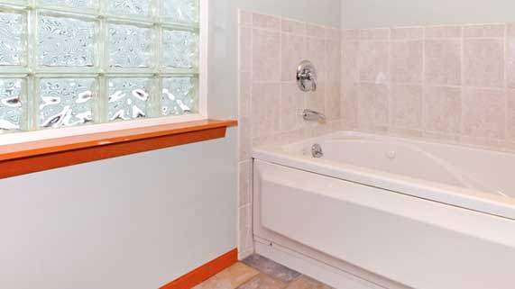
Question 1

A bathroom window is made of textured glass blocks.

How do the textured glass blocks affect the quality of light entering the bathroom?

Type your answer here.


Question 2

Why do eyeglasses need to be transparent, but not translucent?

Type your answer here.

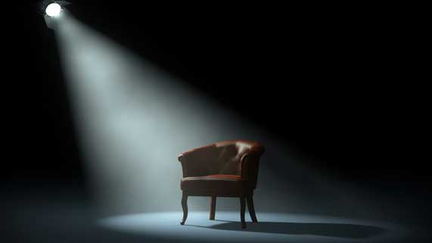
Question 3

Why are theatre spotlights placed high above a stage, instead of directly beside a performer?

Type your answer here.

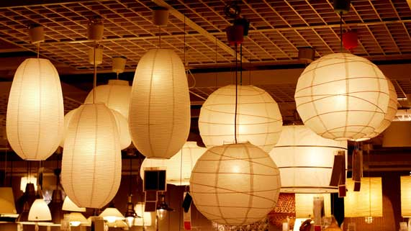
Question 4

Lampshades are often made of a translucent material, like paper.

Why are lampshades made of a translucent material, rather than a transparent material?

Type your answer here.

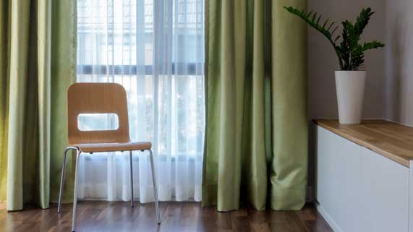
Question 5

Windows are often covered with two sets of curtains: a sheer white curtain and a darker curtain on top.

Why do many windows have two sets of curtains?

Type your answer here.

Congratulations! You have completed this self-check quiz.

Now it's time to carefully compare your answers to the suggested answers in the online course. When comparing, you should feel free to make changes to your answers or make extra notes.

Don't forget to save the quiz whenever you make changes.

Keep this quiz for study purposes. If you want more feedback, share it with your teacher.

