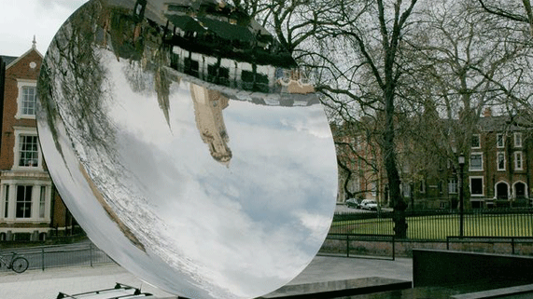
Science 8
Unit C Lesson 4
Lesson Activity
Mirror Image Simulation

Try this online simulation to learn how concave mirrors produce different images.

Instructions:

- Click here to open the simulation.
- Play with the simulation to see what happens when you move the torch to different positions. Click and drag on the torch’s cross-arrow button to move it forward and backward. Click and drag on the torch’s square button to change its size and flip it upside down. Click on the “show rays” and “show grid” buttons to see what happens.
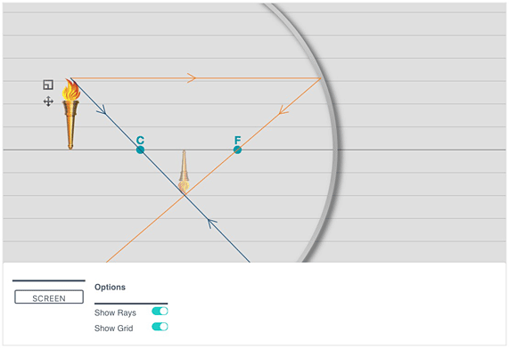
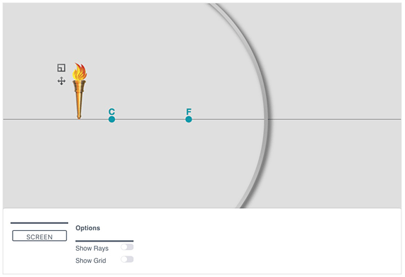
- Adjust the torch’s position to create the images listed in the chart below. A virtual image forms behind the mirror and cannot be projected onto a screen. A real image forms in front of the mirror and can be projected onto a screen.
- Record the position of the torch relative to the focal point (F) and the centre of curvature (C).
- Record the orientation of the torch as right side up or upside down.
- Record the height of the torch.

Observations:

IMAGE |  |  |  | TORCH
Type | Position | Orientation | Height | Position | Orientation | Height
Virtual | As close as possible to mirror | Right side up | 4 units | Between F and the mirror | Right side up | 2 units
Virtual | As close as possible to mirror | Upside down | 4 units
Virtual | As close as possible to mirror | Right side up | 2 units
Virtual | As close as possible to mirror | Upside down | 2 units
Virtual | As close as possible to mirror | Right side up | 6 units
Virtual | As close as possible to mirror | Upside down | 6 units
Real | As far beyond C as possible | Upside down | 4 units
Real | As far beyond C as possible | Right side up | 4 units
Real | Beyond C, but as close to C as possible | Upside down | 4 units
Real | Beyond C, but as close to C as possible | Right side up | 4 units
Real | As far beyond C as possible | Upside down | 2 units
Real | As far beyond C as possible | Right side up | 2 units
Real | Beyond C, but as close to C as possible | Upside down | 2 units
Real | Beyond C, but as close to C as possible | Right side up | 2 units
Real | Between C and F, as close to F as possible | Upside down | 2 units
Real | Between C and F, as close to C as possible | Right side up | 2 units
Real | Between C and F, as close to F as possible | Upside down | 1 unit
Real | Beyond C, but as close to C as possible | Right side up | 1 unit
Real | Image and torch at same position | Right side up | 2 units
Real | Image and torch at same position | Upside down | 2 units
Real | Image and torch at same position | Right side up | 4 units
Real | Image and torch at same position | Upside down | 4 units

Questions:

Think about the following questions very carefully. Then, type or write your answers in space provided. When you have your answers, return to the Lesson C5 page and click the questions for feedback.

- When the torch was located between the focal point (F) and the mirror, what type of image formed? Where was the image located? What size was the image relative to the torch? What orientation (right side up or upside down) was the image relative to the torch?
- When the torch was located between the focal point (F) and the centre of curvature (C), what type of image formed? Where was the image located? What size was the image relative to the torch? What orientation was the image relative to the torch?
- When the torch was beyond the centre of curvature (C), what type of image formed? Where was the image located? What size was the image relative to the torch? What orientation was the image relative to the torch?
- At which location did the concave mirror produce an image the same height as the torch?

