Science 8
Unit C
Lesson 5
Self-Check Quiz

Answer all 5 questions in the spaces provided. Think carefully before typing your answers. If you need help, return to the lesson in the online course. Save your quiz when you are done.

Leave your answers in blue; it will be easier for you and your teacher to see them later.

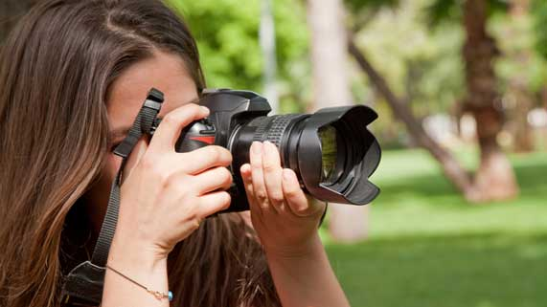
Question 1

In some cameras, photographers have to look through a viewfinder to compose a picture. The camera’s interior contains two mirrors that act like a periscope to direct light up to the viewfinder. Incoming light from the horizontal lens hits the first mirror at a 45-degree angle.
What angle will the incoming light reflect at and where will the light rays travel?

Type your answer here.

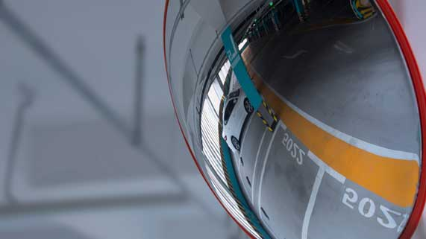
Question 2

A mirror in a parking garage is used to see around corners.

Is a parking garage mirror a flat mirror or a curved mirror? Explain your answer.

Type your answer here.

Question 3

Explain why you can project an image from a concave mirror onto a screen, but you cannot project images from a convex mirror onto a screen.

Type your answer here.

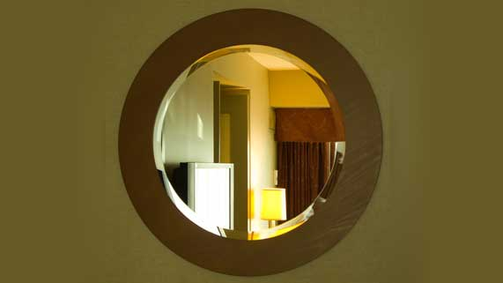
Question 4

Explain why you do not need to stand directly in front of a mirror to still see images in the mirror.

Type your answer here.

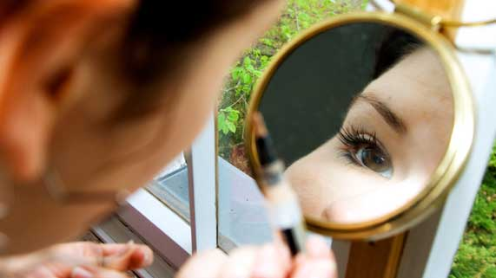
Question 5

A makeup mirror makes your face look bigger when you are very close to the mirror.

What type of mirror is a makeup mirror and why?

Type your answer here.

Congratulations! You have completed this self-check quiz.

Now it's time to carefully compare your answers to the suggested answers in the online course. When comparing, you should feel free to make changes to your answers or make extra notes.

Don't forget to save the quiz whenever you make changes.

Keep this quiz for study purposes. If you want more feedback, share it with your teacher.

