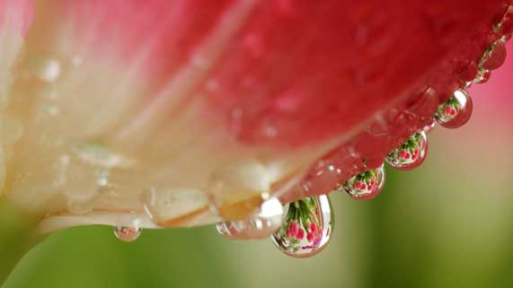
Science 8
Unit C Lesson 6
Lesson Activity
Refraction Simulation

Try this online simulation to explore how light bends in different substances.

Instructions:

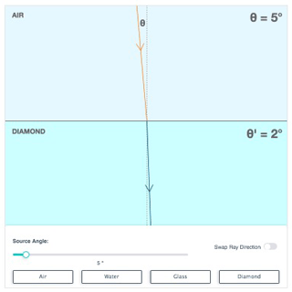
- Open the refraction simulation in the online course.
- Play with the simulation to see what happens when you change different parts of the simulation. Drag the “source angle” slider back and forth. Click the buttons for different substances. Click the “swap ray direction” button.
- Make sure the “swap ray direction” button is off. Set the source angle to 5°. Click through each of the substances to observe the refracted angle. Record your observations in the table in the document you downloaded. Repeat for source angles of 30 and 60°.
Source Angle ° | Refracted Angle °
Air | Air | Water | Glass | Diamond
5 |  |  |  | 2
30
60

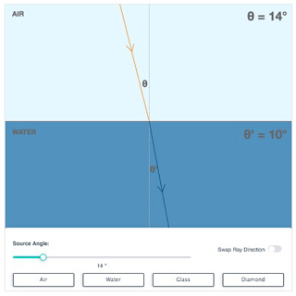
- Make sure the “swap ray direction” button is off. Select air as the refraction substance. Adjust the source angle to create a refracted angle of 10°. Record the corresponding source angle in the table in the document you downloaded. Repeat for refracted angles for 20 and 30°. Repeat for all the other substances.

Air to Air |  | Air to Water |  | Air to Glass |  | Air to Diamond
Source Angle ° | Refracted Angle ° | Source Angle ° | Refracted Angle ° | Source Angle ° | Refracted Angle ° | Source Angle ° | Refracted Angle °
 | 10 | 14 | 10 |  | 10 |  | 10
 | 20 |  | 20 |  | 20 |  | 20
 | 30 |  | 30 |  | 30 |  | 30

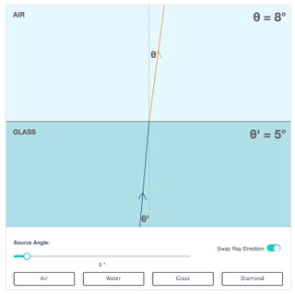
- Turn the “swap ray direction” button on. Set the source angle to 5°. Click through each of the substances to observe the refracted angle. Record your observations in the table in the document you downloaded. Repeat for source angles of 20, 30, and 60°.

Air to Air |  | Water to Air |  | Glass to Air |  | Diamond to Air
Source Angle ° | Refracted Angle ° | Source Angle ° | Refracted Angle ° | Source Angle ° | Refracted Angle ° | Source Angle ° | Refracted Angle °
5 |  | 5 |  | 5 | 8 | 5
20 |  | 20 |  | 20 |  | 20
30 |  | 30 |  | 30 |  | 30
60 |  | 60 |  | 60 |  | 60
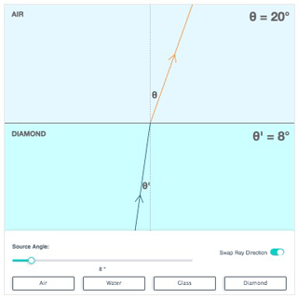
- Make sure the “swap ray direction” button is on. Select air as the source angle substance. Adjust the source angle to create a refracted angle of 20°. Record the corresponding source angle in the table in the document you downloaded. Repeat for refracted angles of 50 and 70°. Repeat for all the other substances.

Source Angle ° |  |  |  | Refracted Angle °
Air | Water | Glass | Diamond | Air
 |  |  | 8 | 20
 |  |  |  | 50
 |  |  |  | 70

- Simulate light entering and exiting a glass windowpane.
  - Turn the “swap ray direction” button off. Select glass as the substance. Set the source angle in air to 50°. What is the refracted angle of light in glass?
  - Turn the “swap ray direction” button on. Adjust the source angle to the same refracted angle of light in glass in Part A. What do you observe about the refracted angle of light back into air?
Questions:

Think about the following questions very carefully. Then, type or write your answers. When you have your answers, click the questions on the lesson webpage for feedback.

- When light travels from air into a denser substance, how does the angle of light change?
- When light travels from air into another substance, which substance bends light the most? Which substance bends light the least? Why?
- As light moved from less dense air into a denser substance, how much did light refract at smaller source angles, as compared to larger source angles?
- When light travels from a more dense substance into air, how does the angle of light change?
- When light travels from a more dense substance into air, when does light bend the most? When does light bend the least? Why?

- When light travels at large angles in a dense substance, why does it internally reflect?
- Explain why we can see objects clearly when light travels through windowpanes, referring to the refraction of light in glass.

