Science 8
Unit C
Lesson 6
Self-Check Quiz

Answer all 5 questions in the spaces provided. Think carefully before typing your answers. If you need help, return to the lesson in the online course. Save your quiz when you are done.

Leave your answers in blue; it will be easier for you and your teacher to see them later.

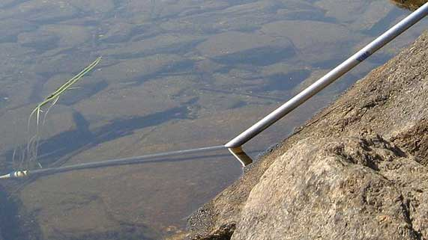
Question 1

Why does a pipe placed into water at an angle appear to bend, when it actually is perfectly straight as it travels down into the water?

Type your answer here.

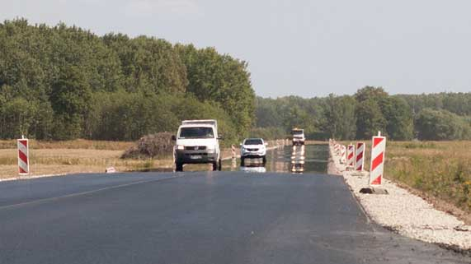
Question 2

A mirage looks like water puddles on the road, reflecting images from the sky. Mirages form on hot days, in the hot, less dense air right over the road.

Why do mirages form in hot, less dense air above road surfaces?

Type your answer here.

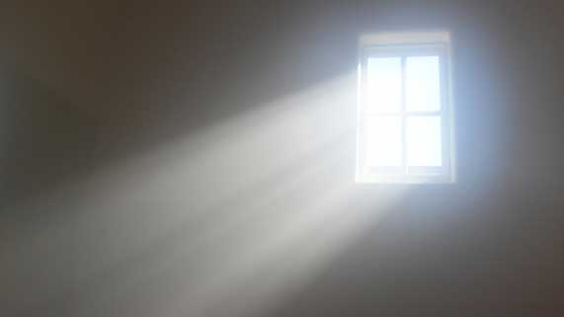
Question 3

Light travels through a transparent glass window.
Describe the shape of the light’s path as it travels into and out of the glass window.

Type your answer here.

Question 4

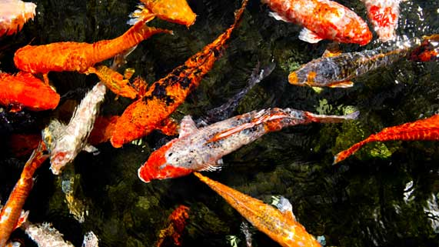
When you look straight down into a pond of water, you can accurately judge the position of objects in the water.

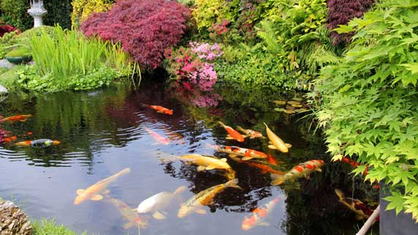However, it is more difficult to accurately judge the position of an object when you look into a pond of water at a side angle.

Explain why viewing pond objects from a side-view angle is not as accurate as viewing objects from a top-view angle.

Type your answer here.

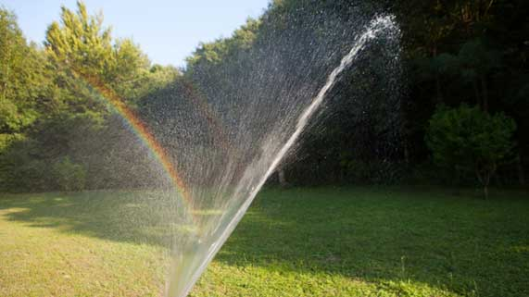
Question 5

Sometimes you can see a rainbow in the spray from a garden hose.

Which way do you have to be facing in order to see a rainbow?

Type your answer here.

Congratulations! You have completed this self-check quiz.

Now it's time to carefully compare your answers to the suggested answers in the online course. When comparing, you should feel free to make changes to your answers or make extra notes.

Don't forget to save the quiz whenever you make changes.

Keep this quiz for study purposes. If you want more feedback, share it with your teacher.

