Science 8
Unit C
Lesson 8
Self-Check Quiz

Answer all 5 questions in the spaces provided. Think carefully before typing your answers. If you need help, return to the lesson in the online course. Save your quiz when you are done.

Leave your answers in blue; it will be easier for you and your teacher to see them later.

Question 1

Why are radio waves used to transmit WiFi internet signals, instead of X-rays?

Type your answer here.

Question 2

When dental assistants take X-rays of teeth, why do they go into another room behind a metal screen, away from the X-ray machine?

Type your answer here.


Question 3

What types of electromagnetic radiation reach Earth’s surface from the Sun? How does your body detect each of these types of electromagnetic radiation?
Type your answer here.

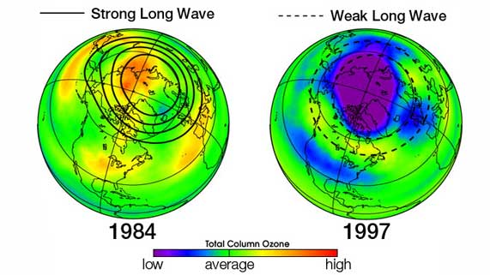
Question 4

Earth has a layer of ozone particles in the high atmosphere. Ozone particles block harmful ultraviolet radiation from reaching Earth’s surface. In the mid 1900’s, chemicals from refrigerators and air conditioners started thinning the ozone layer, especially over Antarctica.
Why is thinning of the ozone layer a problem for humans?

Type your answer here.

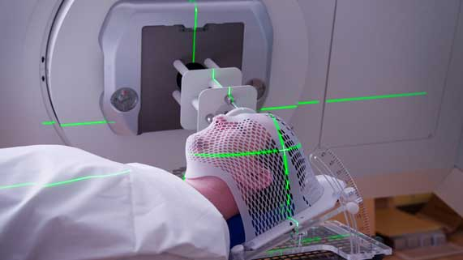
Question 5

Why do gamma rays need to be precisely directed at a tumour during cancer treatment?
Type your answer here.

Congratulations! You have completed this self-check quiz.

Now it's time to carefully compare your answers to the suggested answers in the online course. When comparing, you should feel free to make changes to your answers or make extra notes.

Don't forget to save the quiz whenever you make changes.

Keep this quiz for study purposes. If you want more feedback, share it with your teacher.

