Science 8
Unit C
Section 2
Self-Check Quiz

Answer all 5 questions in the spaces provided. Think carefully before typing your answers. If you need help, return to the lesson in the online course. Save your quiz when you are done.

Leave your answers in blue; it will be easier for you and your teacher to see them later.

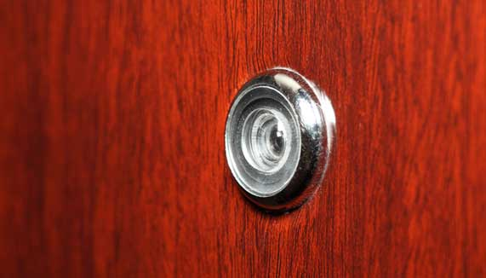
Question 1

A door peephole is a safety device that allows people to see who is outside their door.

Are door peepholes made from a transparent, translucent, or opaque material? Explain your answer.

Type your answer here.

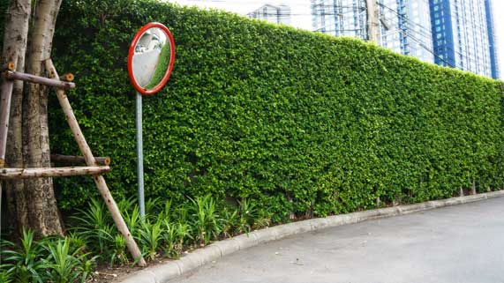
Question 2

A large convex mirror is located at a street corner. The convex mirror allows drivers to see around the corner in advance, for safety.
Explain how a convex mirror allows drivers to see around a corner. Draw a picture with light rays to explain your answer.

Type your answer here.

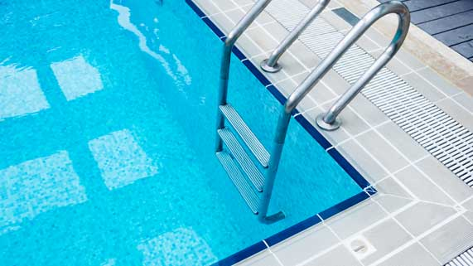
Question 3

Standing on the edge of a swimming pool, the bottom of the pool appears closer than it actually is.
Explain why a swimming pool is deeper than it appears. Draw a picture with light rays to explain your answer.
Type your answer here.

Question 4

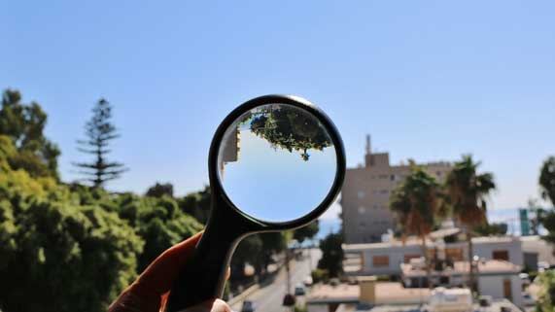Distant objects viewed through a magnifying glass appear upside-down and smaller.
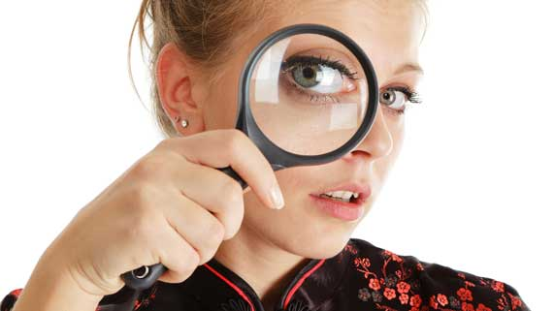Close objects viewed through a magnifying glass appear right-side-up and larger.

Why does a magnifying glass form different images, depending on the location of the object being viewed?

Type your answer here.

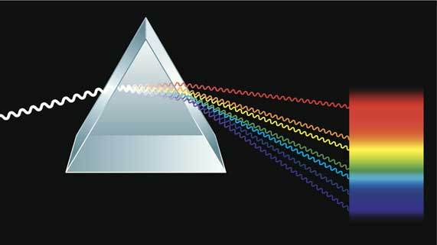
Question 5

Use the wave model of light to explain why white visible light splits into different colours in a prism.
Type your answer here.

Congratulations! You have completed this self-check quiz.

Now it's time to carefully compare your answers to the suggested answers in the online course. When comparing, you should feel free to make changes to your answers or make extra notes.

Don't forget to save the quiz whenever you make changes.

Keep this quiz for study purposes. If you want more feedback, share it with your teacher.

