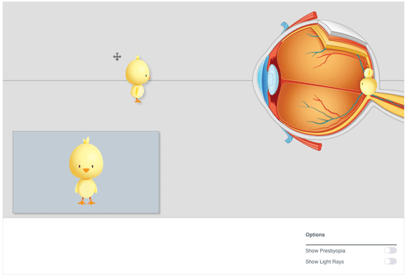
Science 8
Unit C Lesson C9
Lesson Activity
Eye Images

Instructions:

Open the Image Formation Learning Object. Work through the following activities. Type or write your answers to the questions that accompany each activity. When you have your answers, click the questions in the online course for feedback.

Activities & Question:

- Click and drag the cross arrow to slide the bird closer and further away from the eye.
  - When the bird is far away from the eye, how does the retina image change? How does the image you actually see (in the lower left box) change?
  - When the bird is close to the eye, how does the retina image change? How does the image you actually see change?
- Turn on the light rays button. Click and drag the bird closer and further away from the eye.
  - Where do the two light rays always cross?
  - Why does the position of the light rays cause the retina image to form upside down?
  - What happens to the iris and lens as the bird moves closer to the eye?
- Turn on the presbyopia button.
  - Look up presbyopia on the internet. What is presbyopia?
  - Where does the image form when the presbyopia button is turned on?
  - Drag the bird far away from the eye. How does the retina image change? How does the image you actually see change?
  - Drag the bird close to the eye. How does the retina image change? How does the image you actually see change?

