Science 8
Unit C
Lesson 9
Self-Check Quiz

Answer all 5 questions in the spaces provided. Think carefully before typing your answers. If you need help, return to the lesson in the online course. Save your quiz when you are done.

Leave your answers in blue; it will be easier for you and your teacher to see them later.

Question 1

Why do eyes and cameras have adjustable openings?

Type your answer here.

Question 2

A detached retina is a condition in which part of the retina separates from the tissues at the back of the eye. How would a detached retina affect a person’s eyesight?

Type your answer here.

Question 3

Why do eyes and cameras form images with lenses instead of mirrors?
Type your answer here.

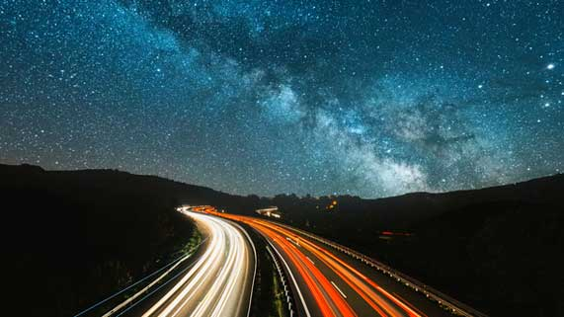
Question 4

When a camera takes pictures at night, why does the shutter need to stay open a long time?

Type your answer here.

Question 5

In an automatic camera, a small motor makes the aperture open and close. What structure in the eye is similar to an aperture motor?
Type your answer here.

Congratulations! You have completed this self-check quiz.

Now it's time to carefully compare your answers to the suggested answers in the online course. When comparing, you should feel free to make changes to your answers or make extra notes.

Don't forget to save the quiz whenever you make changes.

Keep this quiz for study purposes. If you want more feedback, share it with your teacher.

