Science 8
Unit C
Lesson 10
Self-Check Quiz

Answer all 5 questions in the spaces provided. Think carefully before typing your answers. If you need help, return to the lesson in the online course. Save your quiz when you are done.

Leave your answers in blue; it will be easier for you and your teacher to see them later.

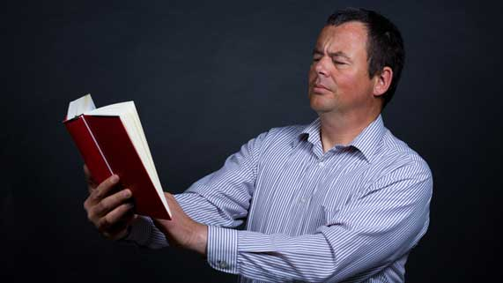
Question 1

After age 40, a man starts to have trouble reading small text from books. His eye’s lens is losing its flexibility. The lens is not able to curve to form a clear image of nearby objects.

What type of vision technology would help this man?

Type your answer here.

Question 2

Explain one advantage and one disadvantage of eyeglass technology.

Type your answer here.

Question 3

Explain one advantage and one disadvantage of laser eye surgery.
Type your answer here.

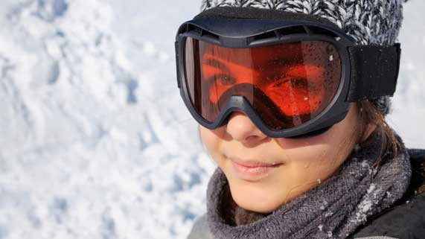
Question 4

Skiers wear dark snow goggles.

Why is it a good idea to wear sunglasses or snow goggles in the winter?

Type your answer here.


Question 5

A student is sitting at the back of the classroom. She has trouble seeing the teacher’s writing on the whiteboard at the front of the room.

What type of vision technology would help this student?
Type your answer here.

Congratulations! You have completed this self-check quiz.

Now it's time to carefully compare your answers to the suggested answers in the online course. When comparing, you should feel free to make changes to your answers or make extra notes.

Don't forget to save the quiz whenever you make changes.

Keep this quiz for study purposes. If you want more feedback, share it with your teacher.

