Science 8
Unit C
Lesson 11
Self-Check Quiz

Answer all 5 questions in the spaces provided. Think carefully before typing your answers. If you need help, return to the lesson in the online course. Save your quiz when you are done.

Leave your answers in blue; it will be easier for you and your teacher to see them later.

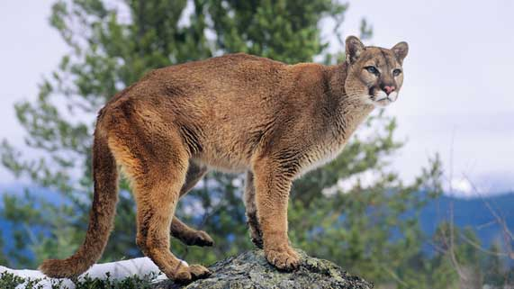
Question 1

Cougars have more rods than cones on the retinas of their eyes.

How does this adaptation help cougars survive?

Type your answer here.

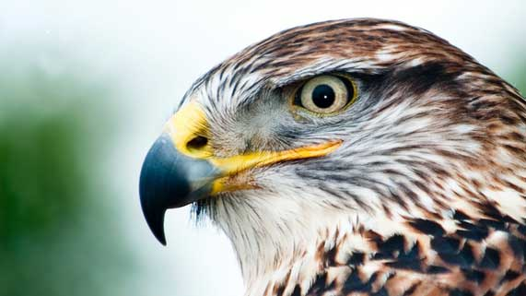
Question 2

Why do many raptor birds like hawks and owls have big eyes for their body size?

Type your answer here.

Question 3

Explain one similarity between camera and compound eyes.
Type your answer here.

Question 4

Explain one difference between camera and compound eyes.

Type your answer here.

Question 5

Why is colour vision an important adaptation for many animals?
Type your answer here.

Congratulations! You have completed this self-check quiz.

Now it's time to carefully compare your answers to the suggested answers in the online course. When comparing, you should feel free to make changes to your answers or make extra notes.

Don't forget to save the quiz whenever you make changes.

Keep this quiz for study purposes. If you want more feedback, share it with your teacher.

