Science 8
Unit C Lesson 12
Try It!
Disappearing Colour Wheels

Try making some spinning colour wheels to demonstrate additive colour mixing.


Materials:

- Cardboard
- White paper
- Pencil
- Round object (like a jar lid)
- Scissors
- Glue
- Ruler
- Colouring markers (red, green, and blue)
- String (1 meter)

Instructions:

- Use the round object and a pencil to trace one circle on a piece of white paper and one circle on a piece of cardboard. You may want to use the templates are available on the next page.
- With a pencil, mark the center of the white paper circle. Use the ruler to divide the circle into six equal pie-shaped sections.
- Color two opposite sections on the circle red. Color two opposite sections on the circle blue. Color two opposite sections on the circle green.
- With scissors, cut out the white paper circle and the cardboard circle.
- With the coloured side facing outward, glue the white paper circle on top of the cardboard circle. Let dry.
- Use the sharp pencil or scissors to poke two side-by-side holes near the center of the glued circle.
- Thread the string through both holes. Tie the string ends together to form a loop.
- With both hands, pull the string loop apart and move the circle to the middle. Spin the circle to twist the string.
- Pull back and forth on both ends of the string loop. What do you observe?

Templates:
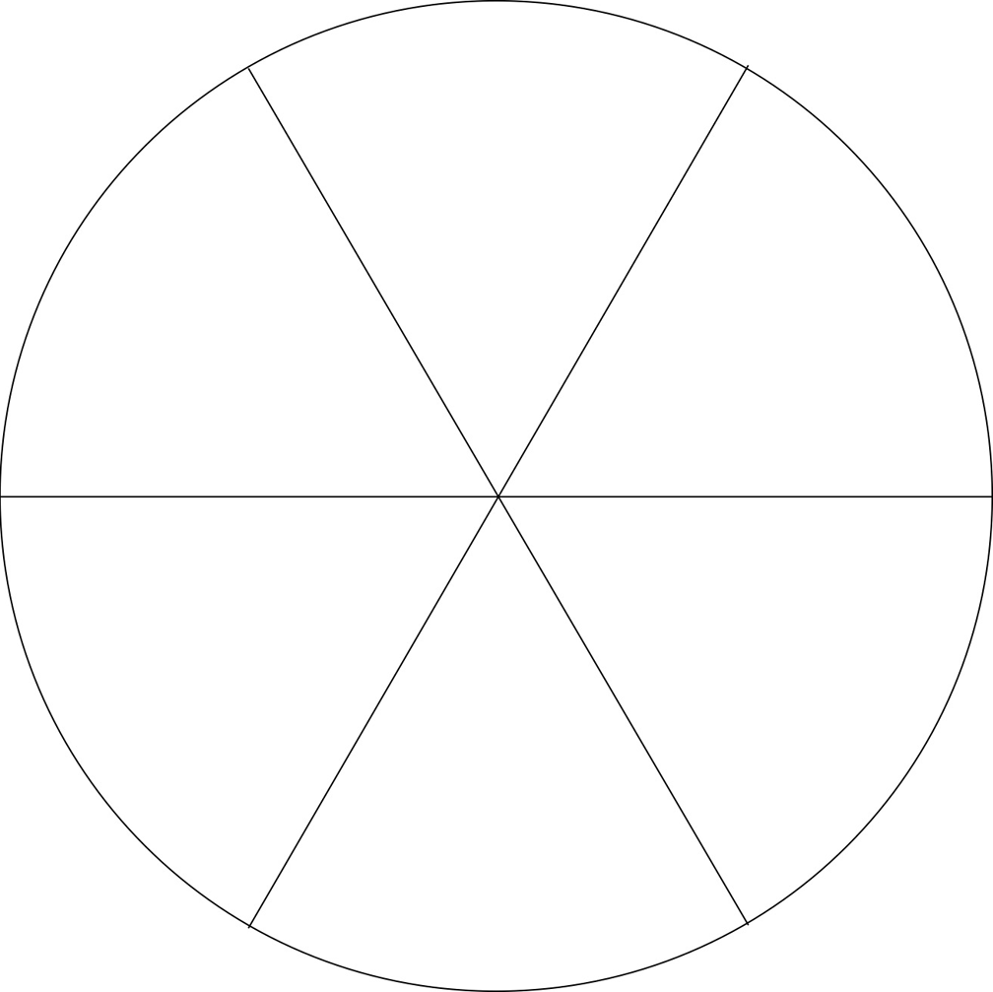

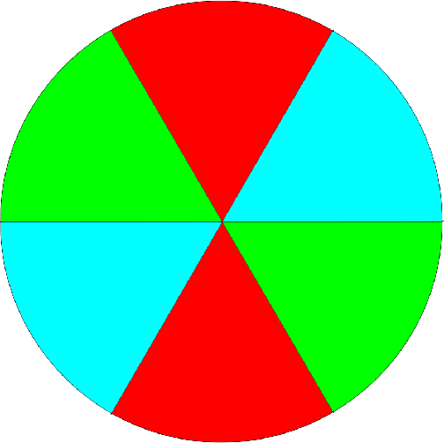

Questions:

Think about the following questions very carefully. Then, type or write your answers. When you have your answers, click the questions in the online course for feedback.

- Why did the spinning circle appear to be white?
- What would you expect to see if you made another spinning circle with alternating red and green sections? (Make another spinning circle and test your hypothesis if you like!)

