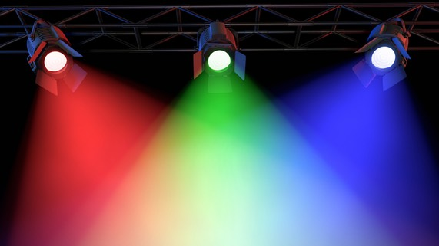
Science 8
Unit C Lesson 12
Try It!
Mixing Light

Screens emit different amounts of red, green, and blue light, to make the brain perceive different colours. Try this online simulation to see what happens when red, green, and blue light combine in different proportions.

Instructions:

- Click the link in Lesson C12 to open the simulation.
- Select and click on the icon that says “RGB” Bulbs, like in the picture below.

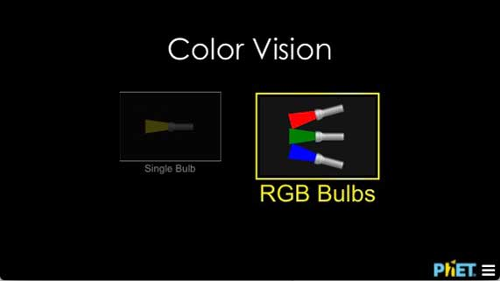
- Adjust the colour light sliders to the following combinations and record what colour you see in the chart below. You can make your own or use the one on the next page.

- “Full” means to move the light slider all the way to the top, turning on the light completely.
- “Half” means to move the light slider halfway to the top.
- “Off” means to move the slider all the way to the bottom, turning off the light completely.

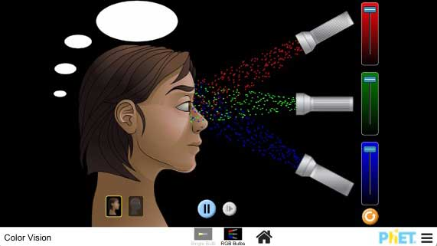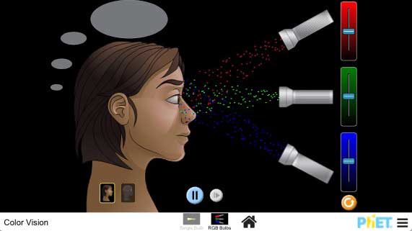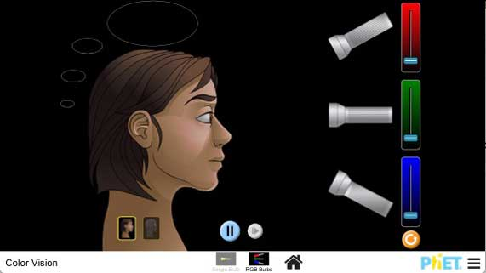

Observations:

Red Light | Green Light | Blue Light | Resulting Colour
Full | Full | Full | White
Full | Full | Off
Full | Off | Full
Off | Full | Full
Full | Half | Off
Half | Full | Off
Half | Off | Full
Full | Off | Half
Off | Full | Half
Off | Half | Full
Half | Half | Half

Questions:

Think about the following questions very carefully. Then, type or write your answers in the document you downloaded. When you have your answers, click the questions in the online course for feedback.

- Why do you think computer and TV screens emit red, green, and blue light?
- Did the colour combinations of light surprise you in any way? How was this activity different from what you might have previously learned about combining colours?

