Science 8
Unit C
Section 3
Self-Check Quiz

Answer all 5 questions in the spaces provided. Think carefully before typing your answers. If you need help, return to the lesson in the online course. Save your quiz when you are done.

Leave your answers in blue; it will be easier for you and your teacher to see them later.

Question 1

An upside-down image forms on a camera’s sensor. Why do you see the image as right-side-up on the camera’s back screen? What similar process happens in the human eye?

Type your answer here.

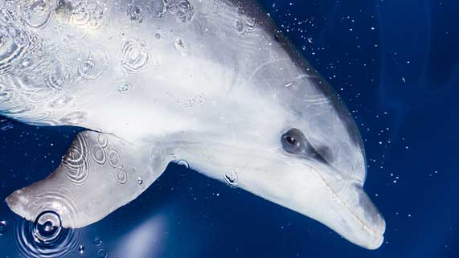
Question 2

Dolphins have only one type of cone on the retina of their eyes. How does this affect the vision of dolphins?

Type your answer here.

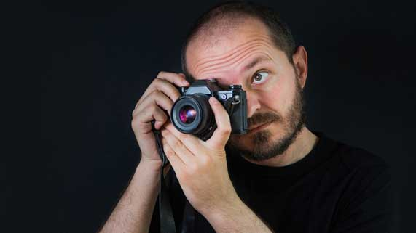
Question 3

A man uses an automatic camera to take a picture indoors in a room with dim lighting.

Explain what part of the man’s camera will automatically adjust to the dim lighting.
Type your answer here.

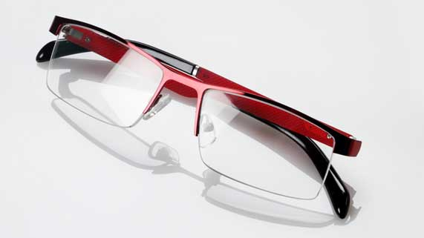
Question 4

Why are lenses, but not mirrors, used in eyeglasses to correct vision problems?

Type your answer here.

Question 5

What is the main advantage of using light in communications technologies, such as internet data transfer?

Type your answer here.

Congratulations! You have completed this self-check quiz.

Now it's time to carefully compare your answers to the suggested answers in the online course. When comparing, you should feel free to make changes to your answers or make extra notes.

Don't forget to save the quiz whenever you make changes.

Keep this quiz for study purposes. If you want more feedback, share it with your teacher.

