Science 8
Unit C
Project
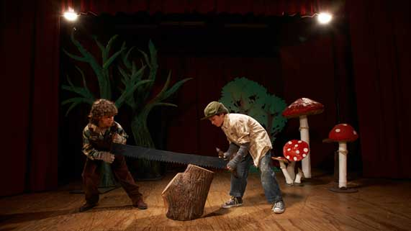
Theatre Lighting Design

You are required to submit the following project to your teacher for marks. Very carefully, read the project and how to do it. Be sure to read the requirements and rubric, they explain the expectations for this project and how it will be marked.

Situation

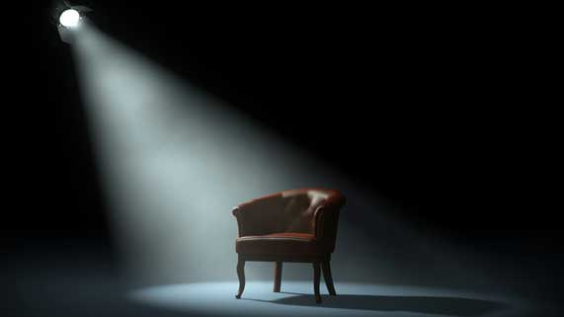
Theatre plays tell a story with live actors. Plays are usually held indoors on stages. The theatre stage must be lit so that the audience can see the actors. Stage lighting designers decide on the type and sequence of lights, in order to create a lighting design that contributes to the mood and emotions of the play.

A youth theatre company in your community needs a volunteer to create a lighting design for their upcoming play. Can you make a lighting design plan that meets the play director’s requirements?

Project Task

Design a lighting plan for a theatre play. The director of the play would like to incorporate a variety of special lighting effects to create particular moods in different parts of the play.

The lighting design should include pictures as well as written information. Search online for “Examples of stage lighting designs” if you are not sure what they look like.

As you create your lighting design, ask yourself these questions:
- What are the characteristics of light and how does my lighting design use these characteristics?
- How can I change the direction and quality of light to create special lighting effects?

How

Choose the way you would like to share your lighting design plan. Here are some ideas from which you can choose:

- Draw a plan on paper with pencil, paper, and coloured pencils.
- Design a plan in a computer drawing program such as Adobe Photoshop or Gimp.
- Build a model of the stage lighting using recycled objects around your house
- Write a descriptive report
- Use other creative ideas, but check with your teacher first!

Requirements

- The play director’s stage lighting requirements are listed below. You must clearly communicate how you will meet these requirements in your theatre lighting plan, so you should strongly consider using these requirements as a way to organize your theatre lighting plan. For example, you might choose to answer the questions in detail as part of a descriptive report. Or, you might draw pictures with notes added for extra explanation. Whatever you choose to do, just make sure you meet all the requirements!

Curtain Design

- A curtain must be hung behind the stage so that when actors are backstage, they are hidden from the audience. Choose an appropriate material for the backstage curtain and explain the scientific reason for why you made that choice.
- One scene in the play is set on a foggy day. The director would like the actors to be present on stage for this scene but hidden from direct view. The director would like the motions of the actors to appear as shadows through large curtains, instead of the actors being directly visible by the audience. Choose an appropriate material for the shadow curtains and explain the scientific reason for why you made that choice. Where will the curtains, actors, and lights need to be positioned to create shadows?

Stage Image Design

- During one scene of the play, an actor feels very confused. The director would like to create a mood of confusion with lighting, by creating images at different angles of the actor on stage. The audience would be able to see many images of the actor at once. Choose an appropriate material to make these images and explain the scientific reason for why you made that choice.

Spotlight Design

- There are three different types of spotlights in the theatre: red, green, and blue. Many scenes in the play require white light to represent daylight. One scene in the play requires yellow light to simulate a sunrise. Another scene in the play requires turquoise light to simulate a tropical ocean. Plan the combination of coloured lights that you will use to create these lighting situations.
- The director wants some spotlights to be small and focused, and other spotlights to cover a wide area. What kind of lenses would you use in spotlights to create each situation? Explain the scientific reasons for your choices.

Projected Image Design

- During one scene of the play, the director wants to project images of a city on a screen behind the actors. Choose an appropriate projection technology for the projected images, and explain how the projection technology works.

Rubric

A rubric explains how your work will be evaluated. It explains clearly all the aspects you must include in your project. Read it very carefully before you start your work.

Theatre Lighting Design
24 marks

CRITERIA | PERFORMANCE
CRITERIA | NOT SUBMITTED | NOT OK | OK | GOOD | EXCELLENT
CRITERIA | Not Submitted  0 marks | Does not meet criteria  1 mark | Minimally meets criteria  2 marks | Fully meets criteria  3 marks | Exceeds criteria  4 marks
Curtain design connected to the properties of light | Not Submitted | No curtain designs listed or connected to properties of light; details lacking | Curtain designs listed but not connected to properties of light; details lacking | Curtain designs listed and connected to properties of light; some supporting details | Curtain designs listed and connected to properties of light; many supporting details
Stage image design connected to the properties of light | Not Submitted | No stage image design listed or connected to properties of light; details lacking | Stage image design listed but not connected to properties of light; details lacking | Stage image design listed and connected to properties of light; some supporting details | Stage image design listed and connected to properties of light; many supporting details
Spotlight design connected to the properties of light | Not Submitted | No spotlight designs listed or connected to properties of light; details lacking | Spotlight designs listed but not connected to properties of light; details lacking | Spotlight designs listed and connected to properties of light; some supporting details | Spotlight designs listed and connected to properties of light; many supporting details
Projected image design connected to the properties of light | Not Submitted | No projected image design listed or connected to properties of light; details lacking | Projected image design listed but not connected to properties of light; details lacking | Projected image design listed and connected to properties of light; some supporting details | Projected image design listed and connected to properties of light; many supporting details
Creativity | Not Submitted | Stage lighting design is very simple and lacks imagination | Stage lighting design is very simple but shows some imagination | Stage lighting design has a few details and shows some imagination | Stage lighting design has many details and shows a great deal of imagination
Communication | Not Submitted | Information is not clearly communicated; details lacking | Information is partly communicated; some details lacking or confusing. | Information is partly communicated but descriptions brief | Information is clearly communicated with much detail and clarity

Submitting Your Work

If you do this project as pencil drawing(s) on another piece of paper, you will have to scan your work to submit it.

If you have prepared any other electronic images or documents for this project, you will need to submit them. The same goes for any Internet location where your work is located, you will need to submit the URL so your teacher can view your work.

When you are ready to submit your completed project, return to the Moodle project page in your course and click the “Add submission” button at the bottom of the page and follow the directions.

Note that when you submit anything to your teacher, PLEASE INCLUDE YOUR NAME IN THE DOCUMENT TITLE. For example, you might title it something like this:

UnitC_unit_project_Jenny_Smith.doc

