Science 8
Unit D
Pre-assessment Quiz

Answer all 4 questions in the spaces provided. Think carefully before typing your answers. Save your quiz when you are done.

Leave your answers in blue; it will be easier for you see them later. If you choose to send this to your teacher, it will be easier for them to see your answers as well.

Question 1

List six simple machines.

Type your answer here.

Question 2

Why is it easier to push a heavy box up a ramp compared to lifting it straight up?

Type your answer here.

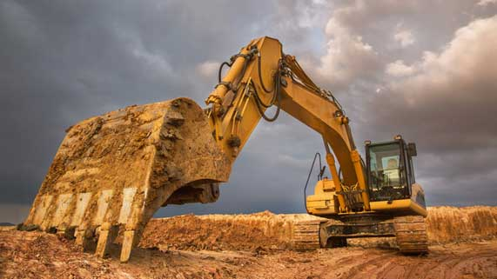
Question 3

What makes the digging arm of an excavator move?

Type your answer here.

Question 4

What are some new types of machines that people are starting to use?

Type your answer here.

