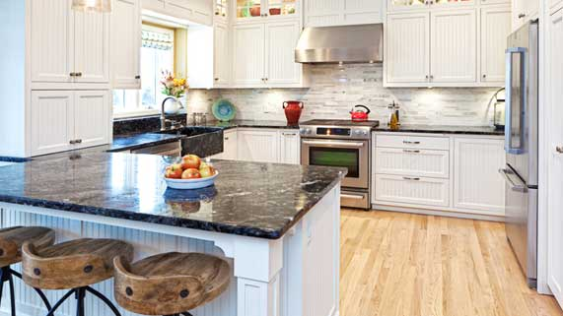
Science 8
Unit D Lesson 1
Try It!
Simple Machine Scavenger Hunt

Try this scavenger hunt to find examples of simple machines around your house.

Instructions:
- Find ten machines around your house that contain at least one simple machine. Good places to look are kitchen drawers and cupboards, tool boxes, and in the garage.
- Examine each item carefully. On the scavenger hunt chart, list the item and the simple machines in it. One example has been given to you. Try to find at least one example of each simple machine for your chart.
Observations Table:

Object | Lever | Inclined Plane | Wedge | Screw | Wheel and Axle | Pulley
Knife | yes |  | yes

Question:

Examine your chart. Which simple machine was the most common on your chart? Which simple machine was the hardest to find in your house?

Sharing:

Congratulations on completing this activity! Did you find any strange or unusual machines around your home? Consider sharing them in the online course Sharing Forum! Take a photo of it and post it. Your teacher and other students would be interested in seeing different machines.

