Science 8
Unit D
Lesson 1
Self-Check Quiz

Answer all 5 questions in the spaces provided. Think carefully before typing your answers. If you need help, return to the lesson in the online course. Save your quiz when you are done.

Leave your answers in blue; it will be easier for you and your teacher to see them later.

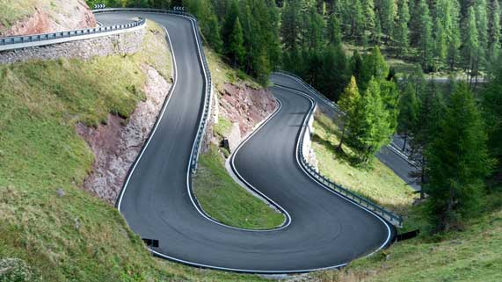
Question 1

Hiking trails or roads on steep mountains often have a zigzag shape. Trails in this shape are called switchbacks.

What type of simple machine are switchbacks and why do switchbacks reduce the effort needed to climb a mountain?

Type your answer here.

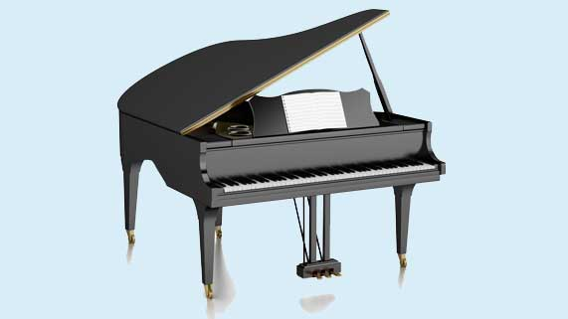
Question 2

A music school wants to move a grand piano to the second floor of their building. The piano is too large to fit up the stairs. There is no elevator in the building, but the building has very large windows.

How could the music school use simple machines to help them move the piano?

Type your answer here.

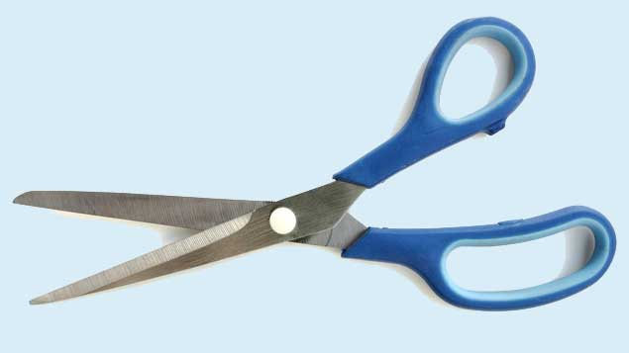
Question 3

A pair of scissors contains two simple machines.

Explain how the simple machines in a pair of scissors make cutting paper easier.

Type your answer here.

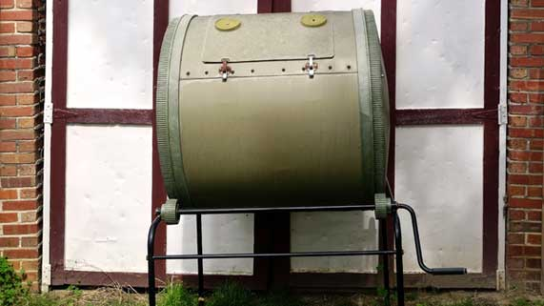
Question 4

Compost materials like vegetable peels and dead leaves need to be mixed in order to form compost faster. Some people use spinning barrel composters to help form compost faster.

What is the main simple machine in a barrel composter, and how does this simple machine help make compost?

Type your answer here.

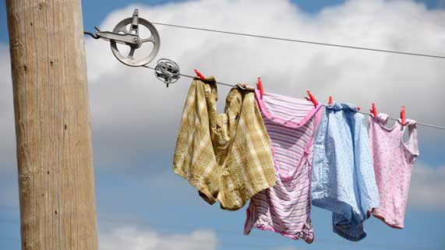
Question 5

A clothesline is made from two pulleys and rope looped around the pulleys. Pulling the upper rope towards you creates empty rope on the bottom rope to hang wet clothing.
What advantage does a pulley clothesline provide?

Type your answer here.

Congratulations! You have completed this self-check quiz.

Now it's time to carefully compare your answers to the suggested answers in the online course. When comparing, you should feel free to make changes to your answers or make extra notes.

Don't forget to save the quiz whenever you make changes.

Keep this quiz for study purposes. If you want more feedback, share it with your teacher.

