Science 8
Unit D
Lesson 2
Self-Check Quiz

Answer all 5 questions in the spaces provided. Think carefully before typing your answers. If you need help, return to the lesson in the online course. Save your quiz when you are done.

Leave your answers in blue; it will be easier for you and your teacher to see them later.

Question 1

Why does improving machines often involve a trial and error experimental process?

Type your answer here.

Question 2

A mixer is a device that has improved over time.

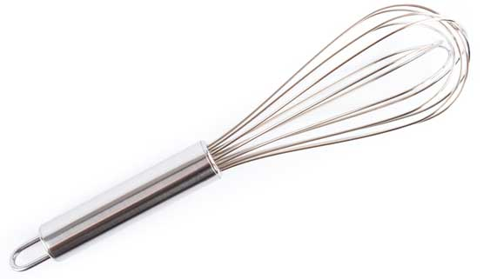

Describe the simple machines in mixers and explain how improvements in their design have made mixers easier to use.

Type your answer here.

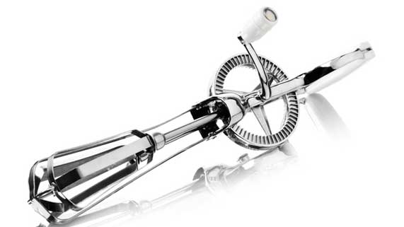

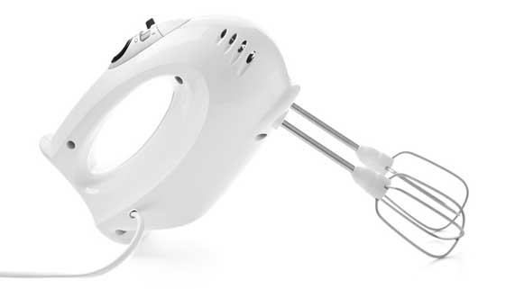

Question 3

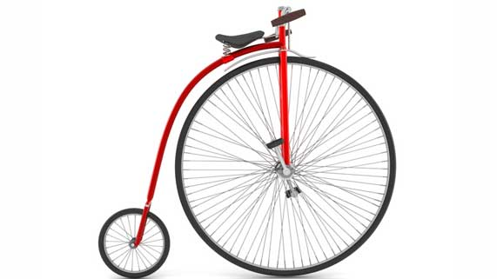

Pennyfarthing bicycles had one large wheel in the front with no chain and gears.

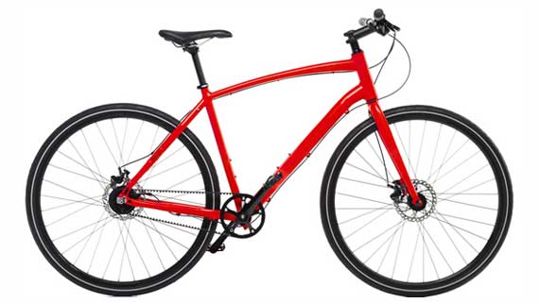

Modern bicycles have two equally sized wheels and a chain and gear system.

Why was the design of the bicycle changed over time?

Type your answer here.


Question 4

Rowboat racers use long paddles attached to the boat. The rower turns the shorter end of the paddle, and the longer end of the paddle is in the water.
What simple machine are rowing paddles? Why does a rower hold the shorter end of the paddle?

Type your answer here.

Question 5

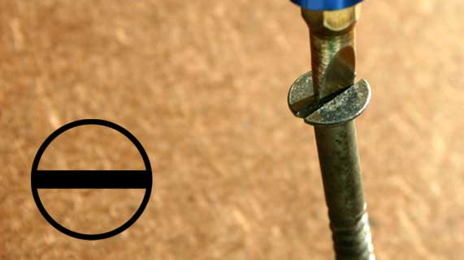

For many years, slotted screws were the only types of screws available.
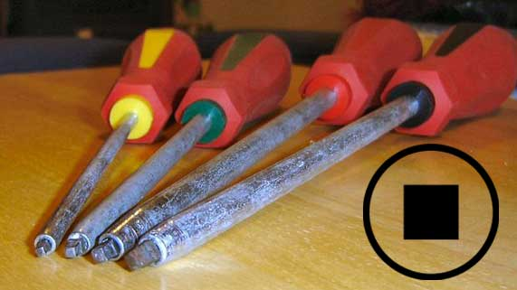

In 1908, the Canadian Peter Robertson invented a square headed screw.

How is the Robertson screw head an improvement over the slotted screw head?

Type your answer here.

Congratulations! You have completed this self-check quiz.

Now it's time to carefully compare your answers to the suggested answers in the online course. When comparing, you should feel free to make changes to your answers or make extra notes.

Don't forget to save the quiz whenever you make changes.

Keep this quiz for study purposes. If you want more feedback, share it with your teacher.

