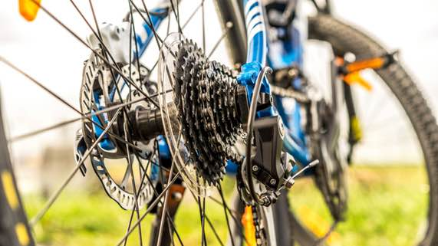
Science 8
Unit D Lesson 3
Try It!
Bicycle Gears

Try this activity to examine how bicycle gears work.

Materials:

- Multi-geared bicycle
- Chalk or pen with white ink

Instructions:

- Switch the bicycle into high gear, with the largest gear connected to the pedals and the smallest gear connected to the back wheel.
- Turn the bicycle upside down so that it is balanced on its seat and handlebars.
- Move the pedal closest to you to its top position.
- Draw a chalk mark on the topmost point of the back bicycle tire, to help you count wheel revolutions.
- Slowly turn the pedal to make one complete revolution. As you turn the pedal, count how many revolutions the back wheel is making.
- When you finish making one pedal revolution, immediately use your hand to stop the back wheel from turning.
- Record the number of revolutions made by the back wheel. If the chalk mark is not at the top of the tire, estimate a fraction for the last revolution.
- Repeat steps 1 to 7 for low gear (smallest gear connected to pedal, largest gear connected to back wheel) and middle gear (pick two gears closest to the middle).
- Watch this video to see this experiment and its results:
https://adlc.wistia.com/medias/4mtqqunzv0

Observations Table:

Gear Combination | Number of Revolutions of Back Wheel
High gear
Low gear
Middle gear

Questions:

Think about the following questions very carefully. Then, type or write your answers. When you have your answers, click the questions for feedback.

- Which gear combination would make the bicycle travel the fastest with the least amount of work?
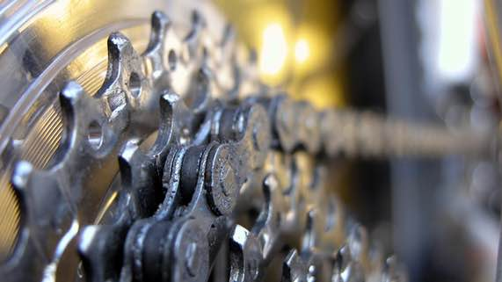
- Which gear combination would be good for a bicycle travelling uphill?

