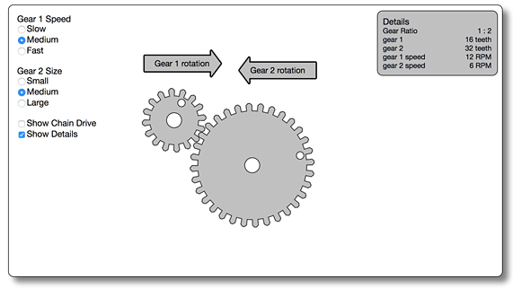
Science 8
Unit D Lesson 3
Lesson Activity
Changing Gear Sizes and Speeds

What is the relationship between rotation speed and direction of rotation when combining gears together?

Instructions:

- Open the gear simulation in the online course.
- In this activity we will assume Gear 1 is providing the force to make the gears turn. That makes Gear 1 the driving gear. Gear 2 is the driven gear.
- Set the Gear 1 Speed to “Medium”.
- Make sure the Gear 2 size is set to “Small”. You will notice the two gears are the same size and have the same number of teeth. Record the number of teeth in the Test 1 row of the Gear Observations table.
- RPM stands for “revolutions per minute”. Record the RPM for each gear in the Test 1 row of the Gear Observations table.
- Increase the Gear 2 size to “Medium”. Record the number of teeth and RPM for each gear in the Test 2 of the Gear Observations table.
- Increase the Gear 2 size to “Large”. Record the number of teeth and RPM for each gear in the Test 3 of the Gear Observations table.
- Click the box next to “Show Chain Drive”. Record the number of teeth and RPM for each gear in the Test 4 of the Gear Observations table.

 | Gear 1 – Driving Gear |  | Gear 2 – Driven Gear
 | Number of Teeth | RPM | Number of Teeth | RPM
Test 1 (gears)
Test 2 (gears)
Test 3 (gears)
Test 4 (chain)

Analysis Questions:

Think about the following questions very carefully. Then, type or write your answers. When you have your answers, click the questions in the online course for feedback.

- What did you observe when the driving gear and the driven gear had the same number of teeth (Test 1)?
- What did you observe when the driving gear was smaller than the driven gear (Tests 2 and 3)?
- What did you observe when the driving gear was larger than the driven gear (Test 4)?
- How does the direction of rotation of meshed gears (gears connected directly together) compare to the direction of rotation of gears connected by a chain?
- How do you think the results of Tests 1, 2, and 3 would change if you changed the Gear 1 Speed to “Slow” or “Fast”? Try it and find out!

