Science 8
Unit D
Lesson 3
Self-Check Quiz

Answer all 5 questions in the spaces provided. Think carefully before typing your answers. If you need help, return to the lesson in the online course. Save your quiz when you are done.

Leave your answers in blue; it will be easier for you and your teacher to see them later.

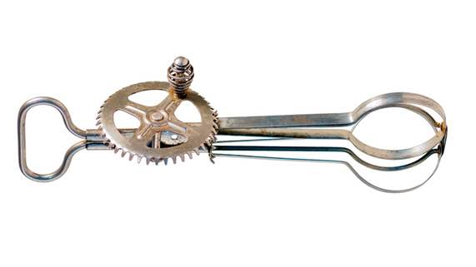
Question 1

Why does a hand beater have a large gear attached to the crank and small gears attached to the whisks?

Type your answer here.

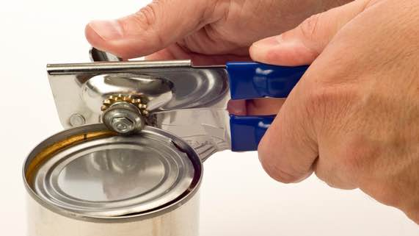
Question 2

A can opener is a complex machine.

What simple machines are found in a can opener and how are these simple machines linked?

Type your answer here.

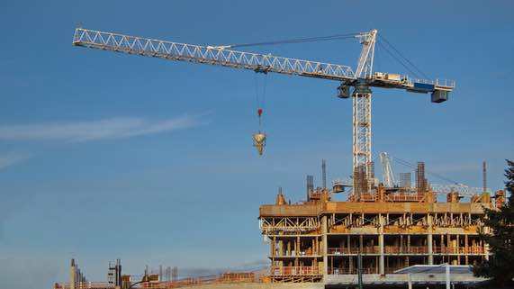
Question 3

A large construction crane is a complex machine that lifts heavy objects.

What are simple machines are found in a construction crane and how are these simple machines linked to reduce the effort of lifting heavy loads?

Type your answer here.

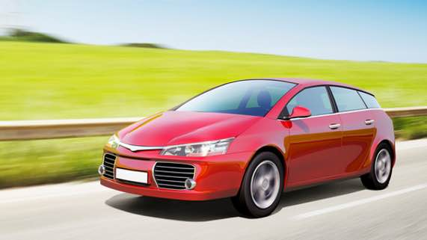
Question 4

List three subsystems in a car. What is the function of each subsystem?

Type your answer here.

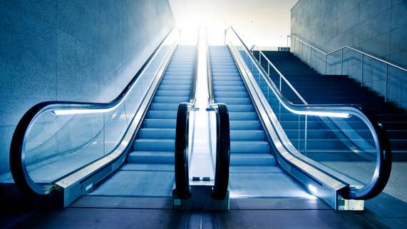
Question 5

An escalator is a complex machine used to move people between building floors. Watch this video to see how an escalator works.

What are simple machines are found in an escalator and how are these simple machines linked?

Type your answer here.

Congratulations! You have completed this self-check quiz.

Now it's time to carefully compare your answers to the suggested answers in the online course. When comparing, you should feel free to make changes to your answers or make extra notes.

Don't forget to save the quiz whenever you make changes.

Keep this quiz for study purposes. If you want more feedback, share it with your teacher.

