Science 8
Unit D
Section 1
Self-Check Quiz

Answer all 5 questions in the spaces provided. Think carefully before typing your answers. If you need help, return to the lesson in the online course. Save your quiz when you are done.

Leave your answers in blue; it will be easier for you and your teacher to see them later.

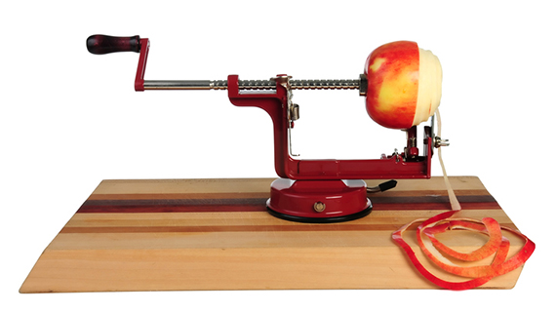
Question 1

An apple peeler is a complex machine.
Name two simple machines in an apple peeler. How are the machines connected and how do they reduce the effort of peeling apples?

Type your answer here.

Question 2

Name one complex machine that you use for transportation. How would your life be different without this machine?

Type your answer here.

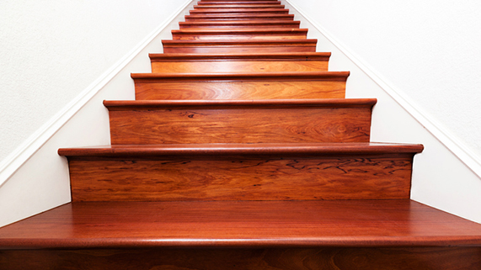
Question 3

Why do we consider stairs to be a simple machine? How do stairs make doing work easier?

Type your answer here.

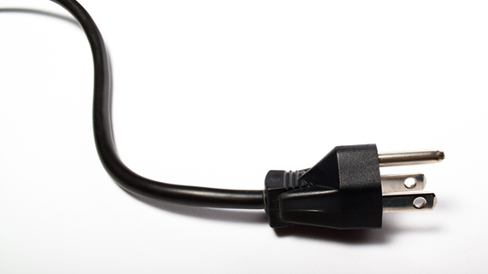
Question 4

Many modern machines are powered by electricity. Why does electricity make doing work easier?

Type your answer here.

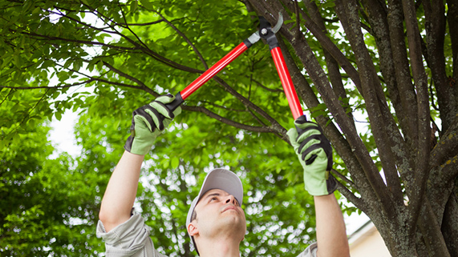
Question 5

Pruning shears are a complex machine used to cut branches on bushes or trees.

Name the two simple machines in a set of pruning shears. How are these simple machines connected and how do they reduce the effort of trimming branches?

Type your answer here.

Congratulations! You have completed this self-check quiz.

Now it's time to carefully compare your answers to the suggested answers in the online course. When comparing, you should feel free to make changes to your answers or make extra notes.

Don't forget to save the quiz whenever you make changes.

Keep this quiz for study purposes. If you want more feedback, share it with your teacher.

