Science 8

Unit D, Section 1
Project
Rube Goldberg Machine

You are required to submit the following project to your teacher for marks. Very carefully, read the project and how to do it. Be sure to read the requirements and rubric, they explain the expectations for this project and how it will be marked.

Situation

Build a Rube Goldberg device to perform a simple task with a complicated, complex machine.

Project Task

1. Choose one of the following simple tasks:

- Turn on a light
- Break an egg
- Squeeze a tube of toothpaste
- Pop a balloon

If you would like to choose a different simple task, check with your teacher first.

2. Design a complex Rube Goldberg machine to accomplish your simple task. You should

- Incorporate at least 4 different simple machines into your Rube Goldberg machine (Lesson D1)
- Incorporate at least 5 steps or subsystems prior to the final step of the machine that accomplishes the task (Lesson D3)
- The design of your Rube Goldberg machine should show imagination and creativity.

Before starting your design, ask yourself this question:

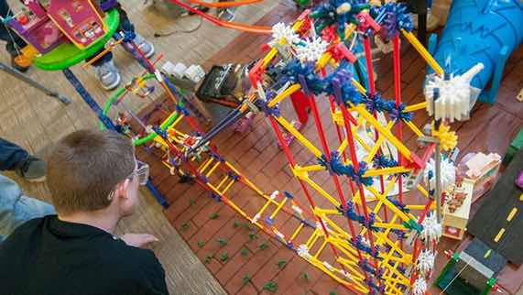

“How can I link all the subsystems of the machine to accomplish the final task?”

Method:

Choose the way you would like to design your Rube Goldberg machine. Here are some ideas from which you can choose:

- Build a working Rube Goldberg machine. Use materials around your house such as marbles, golf balls, toilet paper rolls, plastic containers, tape, string, cardboard, and elastics. Then, photograph or video various aspects of your machine to share with your teacher.
- Draw several pictures to show clearly the features of your design. Use pencil and paper, or use a computer drawing program such as Adobe Photoshop or Gimp.
- Draw a comic strip of your design, just like Rube Goldberg!
- Write a detailed description or story about your design.

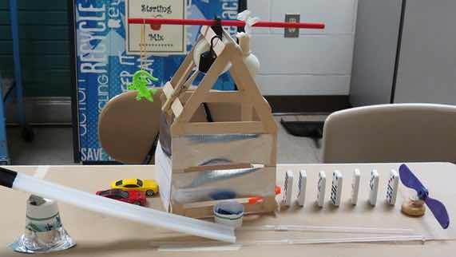
- Use any other creative ideas you have, but check with your teacher first!

Requirements:

You must answer the following questions to communicate clearly the following information about your Rube Goldberg machine.

- You can provide written answers to these questions, or you can include the answers as labels if you produce a drawing or model of your design.
- Another option is to address these questions by recording yourself (and your model or drawings) on video or make an audio recording.

Questions:

- What 4 different simple machines did you use in your design?
- Explain in detail how each simple machine helps accomplish the final task.
- Explain how the 5 subsystems of the machine link together.

Rubric

A rubric explains how your work will be evaluated. It explains clearly all the aspects you must include in your project. Read it very carefully before you start your work.

Rube Goldberg Machine
20 marks

CRITERIA | PERFORMANCE
CRITERIA |  | NOT OK | OK | GOOD | EXCELLENT
CRITERIA | Not Submitted  0 marks | Does not meet criteria  1 mark | Meets criteria minimally  2 marks | Meets criteria fully  3 marks | Exceeds criteria  4 marks
Simple machines identified in design | Not  Submitted | No simple machines identified in design | One simple machine identified in design | Two or three different simple machines identified in design | Four different simple machines identified in design
Simple machine function connected to final task accomplishment | Not  Submitted | No simple machine functions listed or connected to final task accomplishment; details lacking | Some simple machine functions listed or connected to final task accomplishment but are confusing | Simple machine functions listed and connected to final task accomplishment; some supporting details | Simple machine functions listed and connected to final task accomplishment; many supporting details
Subsystem linkages listed and explained | Not  Submitted | No subsystem linkages listed or explained; details lacking | Some subsystem linkages listed or explained but are confusing | Subsystem linkages listed and explained; some supporting details | Subsystem linkages listed and explained; many supporting details
Creativity | Not  Submitted | Design is very simple and lacks imagination | Design is very simple but shows some imagination | Design has some creative features and shows some imagination | Design has creative features and shows great imagination
Communication | Not  Submitted | Design is not clearly communicated; details lacking | Design is partly communicated; some details lacking or confusing | Design is communicated partly; many details included | Design is communicated clearly with much detail

Submitting Your Work

- If you print your work and/or do pencil drawing(s) on another piece of paper, you must scan your work to submit it.
- If you have prepared any other electronic images or documents for this project, you must submit them.
- If you have used an Internet location where your work is located, you must submit the URL so your teacher can view your work.

When you are ready to submit your completed project, return to this project in the online course and follow the instructions at the bottom of the page for submitting your work.

Note that when you submit anything to your teacher, PLEASE INCLUDE YOUR NAME IN THE DOCUMENT TITLE. For example, you might title it something like this:

UnitD_Section1_Project_Jenny_Smith.doc

