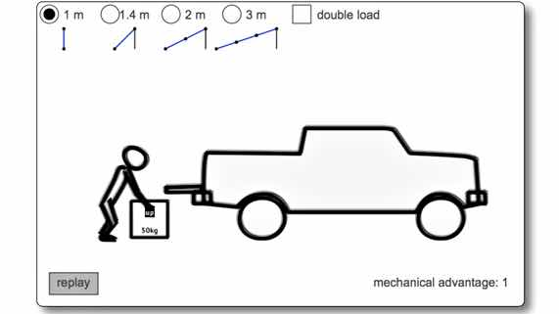
Science 8
Unit D Lesson 4
Lesson Activity
Calculating Work

In this lesson activity, you will explore how force and distance affect work.

Instructions:

- Open the box-lifting simulation in your online course.
- Note that the person in this simulation can apply a maximum force of 600 N. The simulation also assumes that there is no friction between the box and the ramps.
- Click the setting for 1 m. You should see the person lift a 50 kg box up 1 m onto the back of a truck. If you want to see any simulation again, click the “replay” button.
- The force needed to move the load is recorded in the table for you. Calculate and record the work done by the person moving the box into the truck. Record your answer in the observations table. Show your work as well as your final answer. Remember, work equals force times distance. (W = F x d)
- Repeat Steps 3 and 4, for ramps of 1.4, 2, and 3 meters.
- Now click the “double load” box so the person must move two boxes onto the truck.
- Repeat Steps 3 to 5 using the double load.

Observations:

Lifting One Box
*Note – maximum force the person can apply is 600 N

Distance  (metres, m) | Force Needed  (newtons, N) | Work Done  (joules, J)
1.00 | 500
1.40 | 357
2.00 | 250
3.00 | 167

Lifting Two Boxes
*Note – maximum force the person can apply is 600 N

Distance  (metres, m) | Force Needed  (newtons, N) | Work Done  (joules, J)
1.00 | 1000
1.40 | 714
2.00 | 500
3.00 | 333

Questions:

Think about the following questions very carefully. Then, type or write your answers. When you have your answers, click the questions in the online course for feedback.

- For all the ramps, look at the work done to lift one box onto the truck. What do you observe?
- For all the ramps, look at the work done to lift two boxes (double load) onto the truck. What do you observe?
- In general, what effect does increasing the distance of the ramp have on the work required to lift boxes?
- In general, what effect does increasing the distance of the ramp have on the force required to lift boxes?
- Why could the person not lift two boxes (double load) straight up onto the truck? Why could the person not get the two boxes onto the truck using the 1.4 m ramp?
- Why could the person lift two boxes onto the truck, using a 2 m ramp?

