Science 8
Unit D Lesson 4
Try It!
Removing Nails and Screws

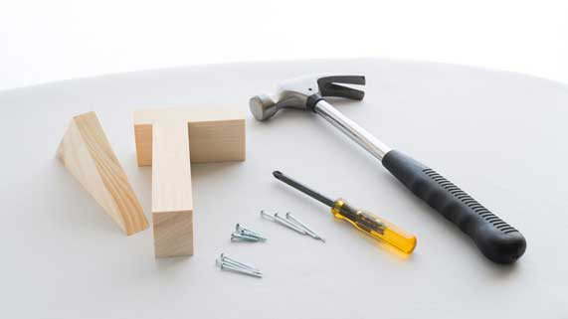
Try this activity to observe the force and distance needed to pull nails and screws out of wood.

Materials:

- Piece of scrap wood
- Hammer
- Nail
- Screw
- Screwdriver

Safety Warning

This activity involves a hammer and nails. It must be completed with the supervision of an adult. DO NOT attempt this activity by yourself.

Hammering and removing sharp nails can hurt you or others if you are not careful.

Instructions:

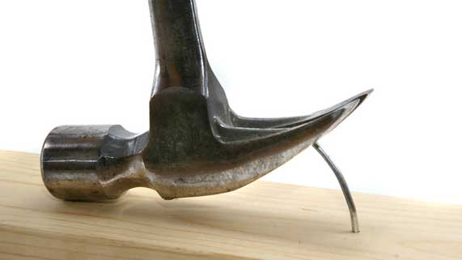
- Hammer the nail into the piece of wood. Leave about 1 cm of the nail sticking out of the wood.
- Try pulling the nail out of the wood directly with your hand. Record the following observations in a table:
- What do you observe about your force input?
- What do you observe about the distance your hand moves?
- Did you do work?

- Use the claw of the hammer to pull the nail out of the wood. Record the following observations in a table:
- What do you observe about your force input?
- What do you observe about the distance the hammer moves?
- Did you do work?

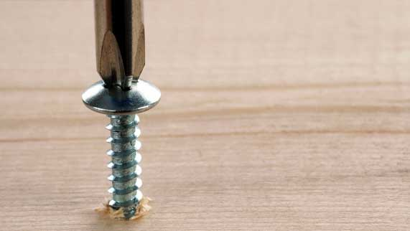
- Turn the screw into the piece of wood. Leave about 1 cm of the screw sticking out of the wood.
- Try turning the screw out of the wood directly with your hand. Record the following observations in a table:

- What do you observe about your force input?
- What do you observe about the distance your hand moves?
- Did you do work?

- Use the screwdriver to turn the screw out of the wood.

- What do you observe about your force input?
- What do you observe about the distance the hammer moves?
- Did you do work?

Observations Table:

Situation | Observation on Force | Observation on Distance | Is Work Done?
Pulling nail out by hand
Pulling nail out with hammer claw
Turning screw out by hand
Turning screw out with screwdriver

Questions:

Think about the following questions very carefully. Then, type or write your answers. After you have your answers, click the questions in the online course for feedback.

- In which situations did you do work and why?

- In which situations did you not do work and why?

- What kind of simple machine is the hammer claw?

- Why was it easier to pull the nail out of the wood with the hammer claw, rather than by hand?

- What kind of simple machine is the screwdriver?

- Why was it easier to pull the screw out of the wood with the screwdriver rather than by hand?

