Science 8
Unit D
Lesson 4
Self-Check Quiz

Answer all 5 questions in the spaces provided. Think carefully before typing your answers. If you need help, return to the lesson in the online course. Save your quiz when you are done.

Leave your answers in blue; it will be easier for you and your teacher to see them later.

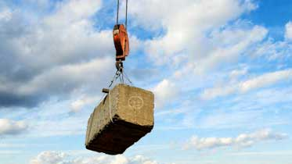
Question 1

A pulley lifts a 400 N stone block 2.00 meters high.

How much work did the pulley do?

Type your answer here.

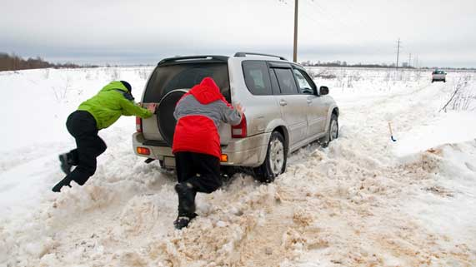
Question 2

Two people push hard against a car stuck in a snowbank. The car won’t move. After a few minutes, one of the people pushing feels really tired. He says, “This is a lot of work!”

Why is the man’s statement incorrect? What could he say instead that would be scientifically accurate?

Type your answer here.

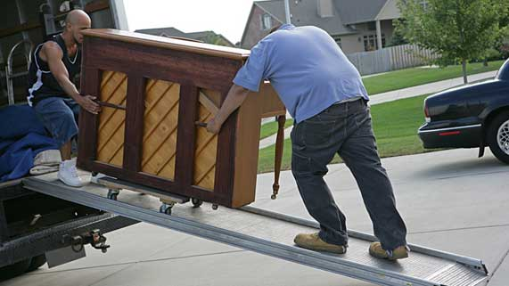
Question 3

A piano takes 1500 J of work to lift into a truck. Piano movers attach a ramp 3.00 m long next to the truck.

What force do the piano movers need to use to roll the piano up the ramp into the truck?

Type your answer here.

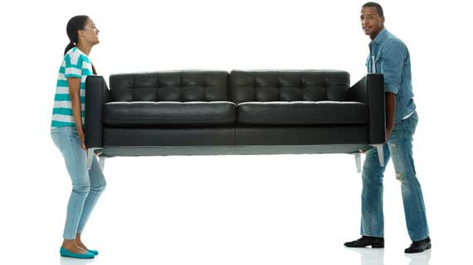
Question 4

You need to move a couch up 2.00 meters to get it into a house. Lifting the couch straight up into the house will take 600 newtons of force. Lifting the couch into the house is much easier with the help of a 4.00 metre ramp.
If you move the couch into the house with the ramp, how much force will you exert?

Type your answer here.

Question 5

“A simple machine makes work feel easier because it helps you do less work”. Why is this statement untrue?

Type your answer here.

Congratulations! You have completed this self-check quiz.

Now it's time to carefully compare your answers to the suggested answers in the online course. When comparing, you should feel free to make changes to your answers or make extra notes.

Don't forget to save the quiz whenever you make changes.

Keep this quiz for study purposes. If you want more feedback, share it with your teacher.

