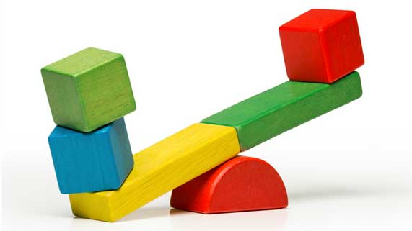
Science 8
Unit D Lesson 5
Think • Interpret • Decide
Which Machine is the Most Efficient?

Instructions:

- A student did an experiment to compare the efficiency of three simple machines. He measured the input work of each machine in lifting a 1-kilogram block.

- First, the student measured the force required to lift the block straight upwards. He lifted the block with a spring scale. It took an applied force of 10.0 newtons lifting the block 2.00 metres straight up. The student used these measurements to calculate the amount of output work needed to lift the block. Remember that the output work is the actual energy required to do a task, not counting any extra energy wasted on friction.

- Next, the student tried lifting the block to a height of 2.00 metres using different simple machines. He measured the input force and distance used to lift the block with the simple machine. His experimental results are shown in the table below.

Lifting a Block With Simple Machines

Simple Machine | Input Force (N) | Input Distance (m) | Input Work (J) | Efficiency
Inclined plane | 5.00 | 5.00
Pulley | 6.00 | 4.00
Lever | 7.00 | 3.00

Questions:

After you have examined the table carefully and carried out calculations to determine the student’s input work and efficiency, carefully consider the following questions. Then, type or write your answers. When you have your answers, click the questions in the online course for feedback.

Think: Do you understand the results of this experiment? If not, look at the experimental results and try the calculations again.

Interpret: How does input work affect a machine’s efficiency? Why are some machines more efficient than others?

Decide: In your view, what is the explanation for differences in the efficiency of these simple machines?

