Science 8
Unit D Lesson 6
Try It!
Broomstick Pulleys

Try this experiment to measure the speed ratio of a pulley system. You will need two other people to help you with this experiment.

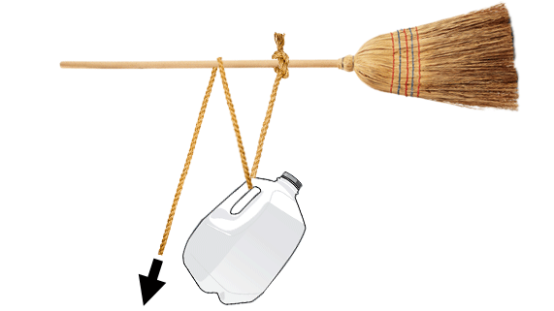
Materials:

- Empty 4 L milk jug with a cap and handle
- Water
- Broom
- Tape measure
- Plastic rope (15 m length)

Instructions:

- Fill the empty milk jug half full with water and close it tightly.
- Have your two helpers hold the broom horizontally, approximately 1 meter high off the floor.

- Loop the rope around the broom handle and tie it together with a knot.
- Place the milk jug on the floor, centered with the broom. Thread the loose end of the rope through the milk jug handle.
- Loop the loose end of the rope back up and over the broom handle. The loose end of the rope should now be hanging loosely on the floor.
- Using the tape measure, adjust the broom handle and the rope so that the broom handle is held 100 cm above the point where the rope is attached to the jug. Have your helpers hold the broom handle at exactly this height. The rope looped around the jug and broom handle should be tight, without lifting the jug off the floor.
- Place a piece of tape at the spot on the rope where it makes its final loop around the broom.
- Pull on the loose end of the rope and lift the jug until the jug handle reaches the height of the broom handle.
- Place a second piece of tape at the new spot on the rope where it makes its final loop around the broom.
- Release the jug.

- Use the tape measure to measure the distance in centimetres between the two pieces of tape on the rope. Record this measurement as the input distance in the observations table.

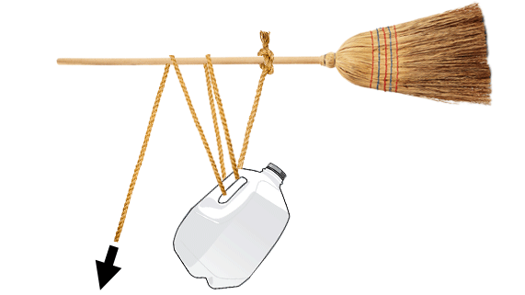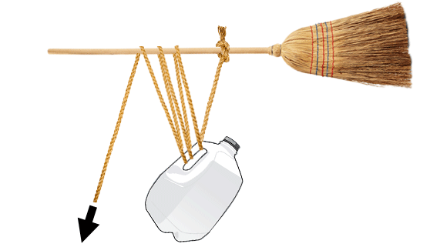

- Repeat steps 2-11, but during step 5, loop the rope through the jug handle and back around the broom a second time.
- Repeat steps 2-12, but after you complete step 5, loop the rope through the jug handle and around the broom handle a third time.

Observations:

Input Distance (cm) | Output Distance (cm) | Speed Ratio

Questions:

Think about the following questions very carefully. Then, type or write your answers. When you have your answers, click the questions in the online course for feedback.

- What was the output distance for each situation in this experiment?

- Calculate the speed ratio for each situation in this experiment. Use the following space for your calculations. Check the answer key in the online course to ensure that your calculations are correct. If not, redo your calculations.

- As you increased the number of pulleys (loops), what happened to the input distance?

- As you increased the number of pulleys (loops), what happened to the speed ratio?

- In this experiment, why did we calculate speed ratio but not mechanical advantage?

- If we measured the input and output force in this experiment to calculate mechanical advantage for each pulley system, how do you expect the MA would compare to the SR?

