Science 8
Unit D
Lesson 6
Self-Check Quiz

Answer all 5 questions in the spaces provided. Think carefully before typing your answers. If you need help, return to the lesson in the online course. Save your quiz when you are done.

Leave your answers in blue; it will be easier for you and your teacher to see them later.

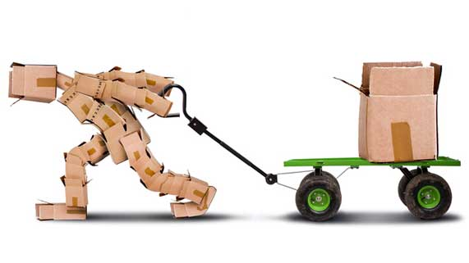
Question 1

It takes 1000 N of force to drag a box along the ground. It takes 400 N of force to pull the same box in a wagon. Calculate the mechanical advantage of the wagon.

Type your answer here.

Question 2

In what situation would mechanical advantage and speed ratio be exactly the same?

Type your answer here.

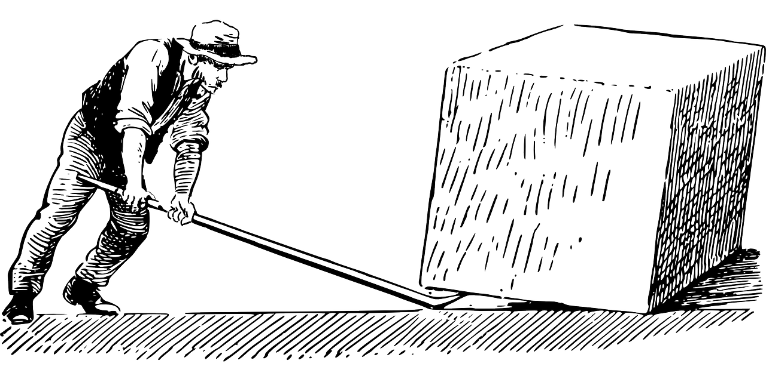
Question 3

A man lifts a heavy rock with a lever. He pushes down with a force of 1000 N, and lifts the rock against the rock’s downward force due to gravity of 1500 N.

What is the mechanical advantage of the lever?

Type your answer here.

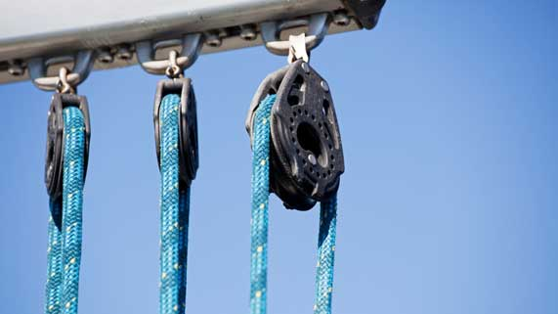
Question 4

A one-pulley system has a mechanical advantage of 1.
Why would you use this machine, if it does not provide any mechanical advantage?

Type your answer here.


Question 5

A tennis racket requires an input force of 300 N to provide an output force of 210 N.

Calculate the tennis racket’s mechanical advantage. What is the benefit of using this machine?

Type your answer here.

Congratulations! You have completed this self-check quiz.

Now it's time to carefully compare your answers to the suggested answers in the online course. When comparing, you should feel free to make changes to your answers or make extra notes.

Don't forget to save the quiz whenever you make changes.

Keep this quiz for study purposes. If you want more feedback, share it with your teacher.

