Science 8
Unit D
Lesson 7
Self-Check Quiz

Answer all 5 questions in the spaces provided. Think carefully before typing your answers. If you need help, return to the lesson in the online course. Save your quiz when you are done.

Leave your answers in blue; it will be easier for you and your teacher to see them later.

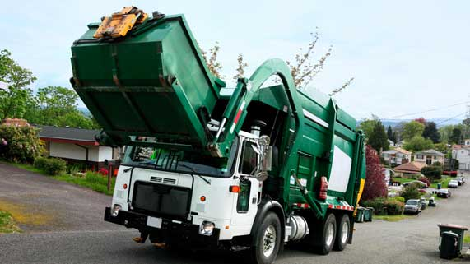
Question 1

Modern garbage trucks use hydraulic systems to lift garbage dumpsters.

Explain why hydraulic levers are a good choice for lifting garbage dumpsters.

Type your answer here.

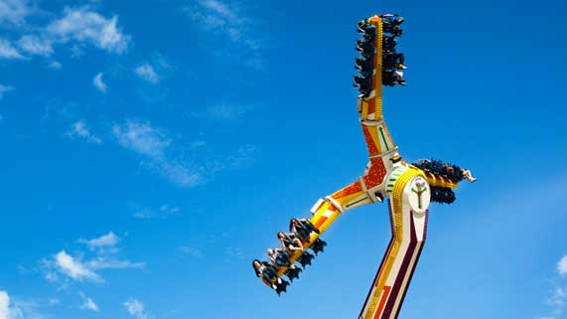
Question 2

Hydraulic systems are used to make amusement park rides tilt at different angles.
Explain how a hydraulic system can be used make a ride tilt.

Type your answer here.

Question 3

Why do people use hydraulic systems instead of pneumatic systems to lift heavy loads?

Type your answer here.

Question 4

Why do large heavy vehicles like trains and buses use pneumatic air brakes, instead of hydraulic brakes, which are typically used on smaller cars?

Type your answer here.

Question 5

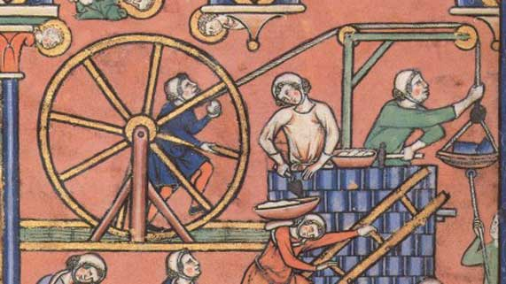In the past, people powered crane levers with a turning wheel.
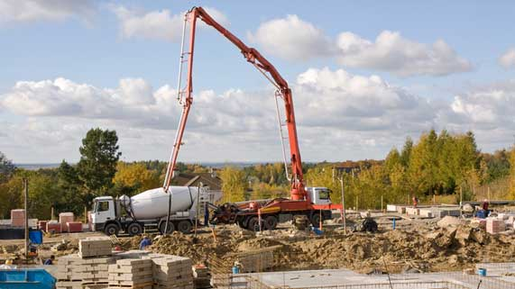Modern crane levers are powered by hydraulic systems.

What is the advantage of using hydraulics in cranes instead of a turning wheel?

Type your answer here.

Congratulations! You have completed this self-check quiz.

Now it's time to carefully compare your answers to the suggested answers in the online course. When comparing, you should feel free to make changes to your answers or make extra notes.

Don't forget to save the quiz whenever you make changes.

Keep this quiz for study purposes. If you want more feedback, share it with your teacher.

