Science 8
Unit D
Lesson 8
Self-Check Quiz

Answer all 5 questions in the spaces provided. Think carefully before typing your answers. If you need help, return to the lesson in the online course. Save your quiz when you are done.

Leave your answers in blue; it will be easier for you and your teacher to see them later.

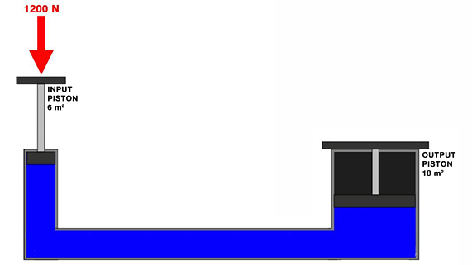
Use the following information to answer the following five self-check questions:

A hydraulic jack has an input piston with an area of 6 m² and an output piston with an area of 18 m². 1200 N of force are applied to the input piston.

Question 1

What is the pressure exerted on the hydraulic fluid by the input piston?

Type your answer here.

Question 2

What is the force exerted by the hydraulic system on the output piston?

Type your answer here.

Question 3

What is the mechanical advantage of the hydraulic jack?

Type your answer here.

Question 4

On this hydraulic jack, does the input piston move the same, less, or more distance compared to the output piston?

Type your answer here.

Question 5

How could you change the area on the output piston to make it move a greater distance while still maintaining a greater force than the input piston?

Type your answer here.

Congratulations! You have completed this self-check quiz.

Now it's time to carefully compare your answers to the suggested answers in the online course. When comparing, you should feel free to make changes to your answers or make extra notes.

Don't forget to save the quiz whenever you make changes.

Keep this quiz for study purposes. If you want more feedback, share it with your teacher.

