Science 8
Unit D
Lesson 10
Self-Check Quiz

Answer all 5 questions in the spaces provided. Think carefully before typing your answers. If you need help, return to the lesson in the online course. Save your quiz when you are done.

Leave your answers in blue; it will be easier for you and your teacher to see them later.

Question 1

In the next 20 years, driverless vehicles like cars, trucks, and buses will increasingly be on the roads. What is one change to society that could happen as a result of these new machines?

Type your answer here.

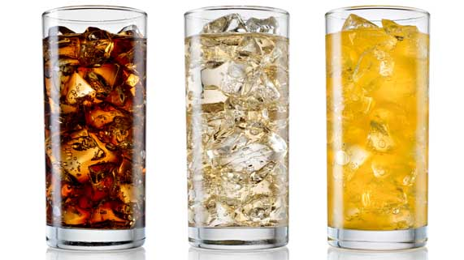
Question 2

A carbonation kitchen appliance puts carbon dioxide bubbles into tap water. The machine holds a reusable canister of carbon dioxide gas. After carbonating a reusable bottle of tap water, people can add flavours to make their own pop.

Explain how a carbonation machine affects the environment in a positive way.

Type your answer here.

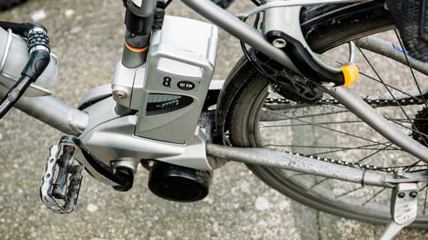
Question 3

Electric bicycles are connected to a small electric motor. A bicyclist can still pedal an electric bike, but turning on the motor helps them ride faster, especially against the wind or uphill.

What are one positive and one negative effect that might occur in society if more people start riding electric bicycles?

Type your answer here.


Question 4

Refrigerators keep food at cool temperatures, which prevents bacterial growth and prevents food from spoiling. In developed countries, refrigerators are found in homes, restaurants, grocery stores, and on ships.

How have refrigerators changed the way that people buy food? How do refrigerators affect the environment?

Type your answer here.

Question 5

List and explain two ways that airplanes have changed society.

Type your answer here.

Congratulations! You have completed this self-check quiz.

Now it's time to carefully compare your answers to the suggested answers in the online course. When comparing, you should feel free to make changes to your answers or make extra notes.

Don't forget to save the quiz whenever you make changes.

Keep this quiz for study purposes. If you want more feedback, share it with your teacher.

