Science 8
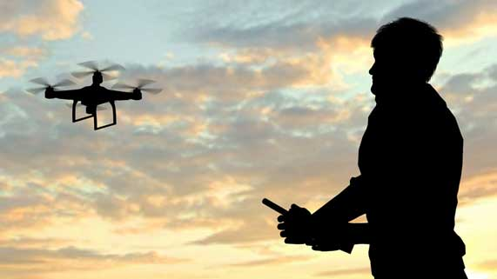
Unit D Lesson 11
Lesson Activity
Drones

Drones are computer-controlled aircraft that do not need a pilot. Drones are also known as unmanned aerial vehicles, or UAVs. Some military drones are small airplanes. Other drones are small personal quadcopters. Drones have many existing and potential uses. However, there are also some drawbacks to drone use.

In this activity, you will learn more about drones. You will collect information about the advantages and disadvantages of drone use.

Instructions:

- Construct a table with two columns. You can do this with a pen and a sheet of paper, or you can use the document you downloaded.
- Title the columns “Examples of Drone Advantages” and “Examples of Drone Disadvantages”.
- Watch these videos. As you watch the videos, listen for examples of advantages and disadvantages to using drones. Pause the video when you hear an example and summarize the example in the correct column of your table.

These videos explore how drones can be useful in disaster situations.
Drones in disasters | Air mule drone

These two videos explain how drones can be used in farming.
Better farming with drones | Bee drones

These two videos explore safety issues involved with drone use.
Personal drones | Drones misbehaving

These two videos explain how drones are used in the military.
Military drones | Drone warfare

These two videos show examples of how drones are used for aerial photography
and videography in different industries.
Real estate drones | OK Go Drones

These videos show how delivery drones work.
Amazon delivery drones | UPS delivery drones

This video explains how scientists use drones to study wild goats.
Medical drones

This video shows how some people misuse drones to invade the privacy of others.
Spying drone

Examples of Drone Advantages | Examples of Drone Disadvantages

Sharing:

Congratulations on completing this activity! Your observations are very important! Consider sharing your advantages and disadvantages of drone technology in the course Sharing Forum. You can also share your own thoughts on drones as well – what is your opinion on drone technology?

