Science 8
Unit D
Section 3
Self-Check Quiz

Answer all 5 questions in the spaces provided. Think carefully before typing your answers. If you need help, return to the lesson in the online course. Save your quiz when you are done.

Leave your answers in blue; it will be easier for you and your teacher to see them later.

Question 1

Explain two types of criteria (criteria are principles or standards) that people use to evaluate machines.

Type your answer here.

Question 2

Why is it important for people to evaluate machines before buying them?

Type your answer here.

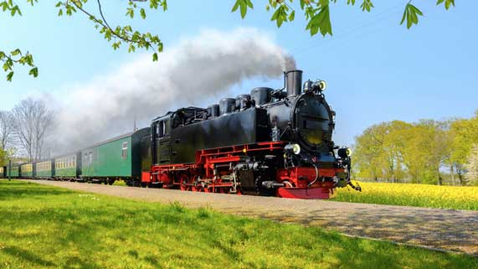
Question 3

Steam-powered trains were invented in the early 1800s. Steam-powered trains were the fastest form of transportation during the 1800s. Coal, a fossil fuel, was burned in early trains, heating water into steam.
Explain one way that steam-powered trains changed society. Explain one impact that steam-powered trains had on the environment.

Type your answer here.

Question 4

List one new technology that has recently been introduced into society. Explain how this technology will affect people’s lives.

Type your answer here.

Question 5

Why do humans keep inventing and improving new machines?

Type your answer here.

Congratulations! You have completed this self-check quiz.

Now it's time to carefully compare your answers to the suggested answers in the online course. When comparing, you should feel free to make changes to your answers or make extra notes.

Don't forget to save the quiz whenever you make changes.

Keep this quiz for study purposes. If you want more feedback, share it with your teacher.

