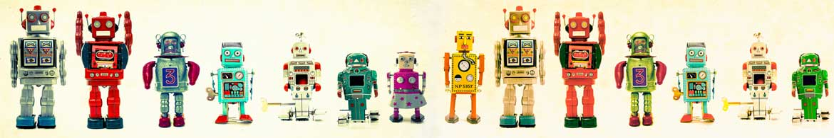
Science 8
Unit D
Project
Design a Robot

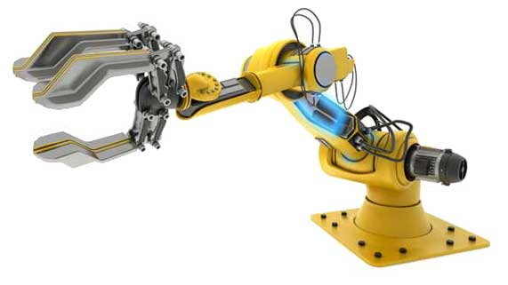
You are required to submit this project to your teacher for marks. Very carefully, read the project and how to do it. Read the requirements and rubric, they explain the expectations for this project and how it will be marked.

Situation

Humans are increasingly using robots to complete tasks that are boring, difficult, dangerous, or time-consuming. Engineers have designed robots that complete everyday household tasks, such as vacuuming and lawn mowing.

Project Task

Choose one job or task that you wish a robot could complete. The task should be a physical task, not a mental task. Design a robot to complete this task.

Your creative robot design should show at least three different simple machines that work together to perform the task. Your robot design should be evaluated by another person.

Before you begin your robot design, ask yourself these questions:

- What are all the steps involved in completing the task? What parts are needed in the robot to complete each step?
- What do I know about how different parts work together in complex machines? If I don’t know, how will I review this information?

Method

- Choose a task for the robot to perform. For example, you could choose one of the following tasks:

- Shovelling snow
- Cutting grass
- Mopping the floor
- Folding clothes
- Cutting hair
- Another task of your choice, but check with your teacher first.

- Choose the way you would like to communicate your robot design. Here are some ideas from which you can choose:

- Draw pictures and diagrams. Draw with pencil and paper, or use a computer drawing program such as Adobe Photoshop or Gimp.
- Build a structure in Minecraft and take screenshots.
- Build a model. Then, photograph or video various aspects of your model to share with your teacher.
- Build an actual working robot with robotics equipment, such as Lego Mindstorms.
- Use other creative ideas, but check with your teacher first!

Requirements

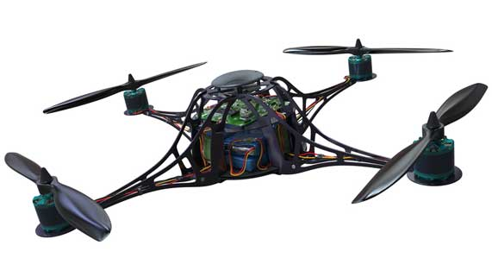
You must answer the following questions to communicate clearly the following information about your robot design.

- You can provide written answers to these questions, or you can include the answers as labels if you produce a drawing of your design.
- Another option is to address these questions by recording yourself (and your model or drawings) on video or make an audio recording.

- Use and label at least 3 simple machines in your robot design. Explain in detail how each simple machine helps to complete the robot’s task.
- What type of energy will power the motion of the robot? What impact does this energy source have on the environment?
- Ask a friend, family member, or another student to evaluate your robot design for effectiveness, appearance, and environmental impact. Show the person your design and record their responses to the following questions:

- Do you think the robot will be effective at its task? Why or why not? What do you think could be improved to make the robot perform its job better?

- What do you like or not like about the robot’s appearance? What would you change about the robot’s appearance?

- How do you think the robot will affect the environment? Will it have a positive impact, a negative impact, or no impact on the environment?

- If your robot could be mass-produced in a factory and sold to consumers, how would the robot change people’s lives in a positive way? How would the robot change people’s lives in a negative way? Explain your answers in detail.

Rubric

A rubric explains how your work will be evaluated. It explains clearly all the aspects you must include in your project. Read it very carefully before you start your work.

Design a Robot
24 marks

CRITERIA | PERFORMANCE
CRITERIA |  | NOT OK | OK | GOOD | EXCELLENT
CRITERIA | Not Submitted  0 marks | Does not  meet criteria  1 mark | Minimally  meets criteria  2 marks | Fully  meets criteria  3 marks | Exceeds  criteria  4 marks
Three different simple machines listed and connected to robot’s function | Not Submitted | No simple machines listed or connected to robot’s function; details lacking | 1 simple machine listed and connected to robot’s function, but is confusing | 2 different simple machines listed and connected to robot’s function; some supporting details | 3 or more simple machines listed and connected to robot’s function; many supporting details
Energy source listed and connected to environmental impact | Not Submitted | No energy source mentioned or connected to environmental impact; details lacking | Energy source mentioned but not connected to environmental impact; details lacking | Energy source mentioned and connected to environmental impact; some supporting details | Energy source mentioned and connected to environmental impact; many supporting details
Robot evaluation criteria completed and recorded | Not Submitted | No evaluation criteria completed or recorded; details lacking | Some evaluation criteria completed and recorded but are confusing | Evaluation criteria completed and recorded; some supporting details | Evaluation criteria completed and recorded; many supporting details
Positive and negative Impact of robot described | Not Submitted | No impacts mentioned or described; details lacking | Impacts mentioned but not described; details lacking | Impacts mentioned and described; some supporting details | Impacts mentioned and described; many supporting details
Creativity | Not Submitted | Design is very simple and lacks imagination. | Design is very simple but shows some imagination | Design has some creative features and shows some imagination. | Design has creative features and shows great imagination
Communication | Not Submitted | Design is not clearly communicated; details lacking | Design is partly communicated; some details lacking or confusing | Design is communicated partly; many details included | Design is communicated clearly with much detail

Submitting Your Work

- If you print your work and/or do pencil drawing(s) on another piece of paper, you must scan your work to submit it.

- If you have prepared any other electronic images or documents for this project, you must submit them.

- If you have used an Internet location where your work is located, you must submit the URL so your teacher can view your work.

When you are ready to submit your completed project, click the "Add submission" button at the bottom of the online course project page and follow the directions.
If you would like to view a tutorial on how to submit your assignment, click here.

Note that when you submit anything to your teacher, PLEASE INCLUDE YOUR NAME IN THE DOCUMENT TITLE. For example, you might title it something like this:

UnitD_project_Jenny_Smith.doc

