Science 8
Unit E
Lesson 1
Self-Check Quiz

Answer all 5 questions in the spaces provided. Think carefully before typing your answers. If you need help, return to the lesson in the online course. Save your quiz when you are done.

Leave your answers in blue; it will be easier for you and your teacher to see them later.

Question 1

Why does salt water in the oceans not meet human needs for drinking water? (Hint – think back to the Mix and Flow of Matter unit)

Type your answer here.

Question 2

Canada contains 20% of the world’s freshwater. Explain two reasons for the abundance of freshwater in Canada.

Type your answer here.

Question 3

During dry summers, some communities ban people from watering their lawns. Why?

Type your answer here.

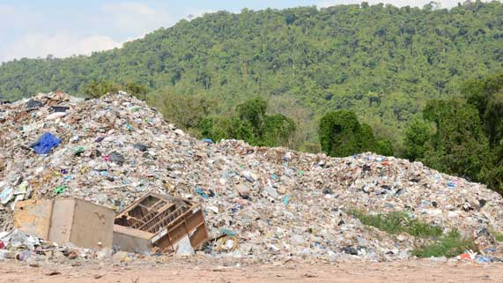
Question 4

Why are new landfills are lined with a layer of clay before garbage is piled on top?

Type your answer here.

Question 5

Explain two ways that people in Alberta use fresh water for purposes other than drinking water.

Type your answer here.

Congratulations! You have completed this self-check quiz.

Now it's time to carefully compare your answers to the suggested answers in the online course. When comparing, you should feel free to make changes to your answers or make extra notes.

Don't forget to save the quiz whenever you make changes.

Keep this quiz for study purposes. If you want more feedback, share it with your teacher.

