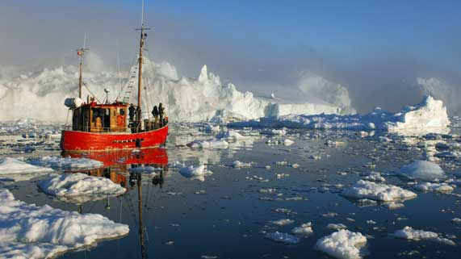
Science 8
Unit E, Lesson 2
Lesson Activity
Frozen Water

Problem:

How does salinity affect the rate at which water freezes? Your task is to design and carry out an experiment testing the rate of freezing for fresh water compared to a saltwater solution.

Hypothesis:

A hypothesis is a testable answer to a scientific question. In other words, what do you think the result of this activity will be? Hint: In this case, think about how you would state a prediction of what would freeze faster; fresh water or a saltwater solution.
Write your hypothesis in the red box.

Variables in this Experiment:

In order to design a fair experiment, you need to know the manipulated, responding, and controlled variables. Review the science skills video on variables if you need to.

Questions:

Write or type your answers to the following questions about variables. When you have written your answers, click on the questions to check your answers.

- What is the responding variable in this experiment?
- What is the manipulated variable in this experiment?
- What is the controlled variable in this experiment?
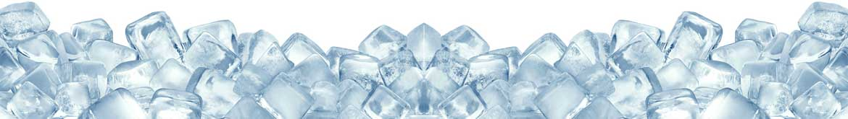

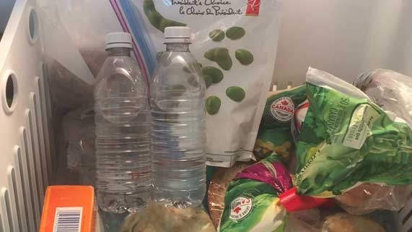
Materials:

- Water
- Salt
- 2 plastic bottles
- Timer
- Thermometer
- Measuring spoons
- Any other materials you think are useful

Instructions:

- Design and write a procedure for this experiment. Remember, you are trying to compare the freezing rate of fresh water to freezing rate of salt water. Write your procedure as numbered steps with enough detail so someone else could easily do the experiment.
Before you start writing your procedure, consider these questions:
- How are you going to measure the responding variable?
- What are all the specific things you need to keep the same in order to make it a fair test?
Your Procedure:

Use the following space to write your procedure. Remember, numbering your steps will help you will help you to keep organized. There are 5 empty steps below, but you can use as many steps as you need.

Step 1.

Step 2.

Step 3.

Step 4.

Step 5.

- Test your procedure by doing the experiment, and record your results in a table like this:

Observations Table

Solution | Time to Freeze
Fresh water
Salt water

Analysis Questions:

Think about the following questions very carefully. Then, type answers in the space provided. When you have your answers, click the questions in the online course for feedback.

- Which solution froze the fastest and why?

- What conclusion can you make about the behaviour of ocean water compared to fresh water at cold temperatures?

