Science 8
Unit E
Lesson 2
Self-Check Quiz

Answer all 5 questions in the spaces provided. Think carefully before typing your answers. If you need help, return to the lesson in the online course. Save your quiz when you are done.

Leave your answers in blue; it will be easier for you and your teacher to see them later.

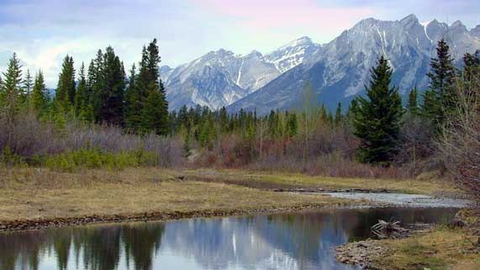
Question 1

On a hiking trip in the forest, your friend sees a clear freshwater stream and suggests you fill up your water bottles.
What could you tell your friend to explain why drinking water straight from a stream is not a good idea?

Type your answer here.

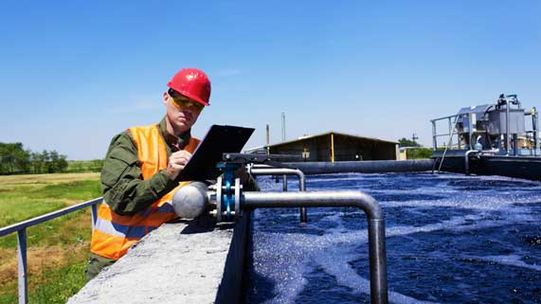
Question 2

Why do cities and towns have large water treatment systems?
Type your answer here.

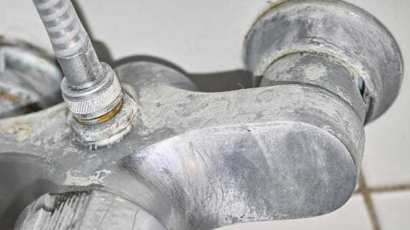
Question 3

On a farm, the well water causes stains around the taps.
What is the likely cause?

Type your answer here.

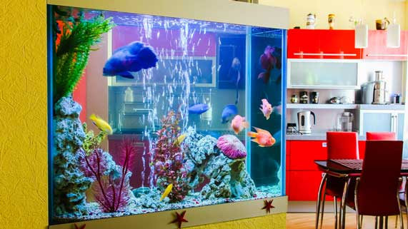
Question 4

Air pumps bubble air into fish aquarium water.
Why do fish aquariums need air pumps?

Type your answer here.

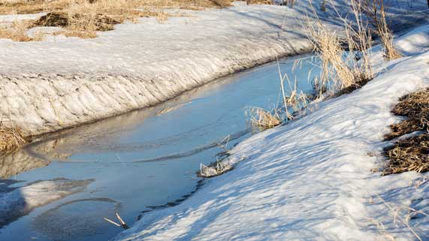
Question 5

In the spring, snow melts from the land and washes into rivers.
Why does tap water often taste more chlorinated in the spring?

Type your answer here.

Congratulations! You have completed this self-check quiz.

Now it's time to carefully compare your answers to the suggested answers in the online course. When comparing, you should feel free to make changes to your answers or make extra notes.

Don't forget to save the quiz whenever you make changes.

Keep this quiz for study purposes. If you want more feedback, share it with your teacher.

