Science 8
Unit E
Lesson 3
Self-Check Quiz

Answer all 5 questions in the spaces provided. Think carefully before typing your answers. If you need help, return to the lesson in the online course. Save your quiz when you are done.

Leave your answers in blue; it will be easier for you and your teacher to see them later.

Question 1

Explain why wastewater treatment plants do not use distillation to separate clean water from sewage.

Type your answer here.


Question 2

Two people want to sail their boat across the Atlantic Ocean. The journey will take about a month. Their storage tanks will run out of fresh water along the way. The sailboat is equipped with solar panels.
What would be a good method for the sailors to obtain fresh water on their boat?
Type your answer here.

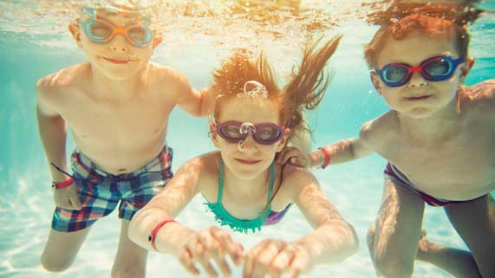
Question 3

Many chlorinated swimming pools are being converted to saltwater pools. Saltwater pools contain sodium chloride salt. A saltwater pool treatment system combines salt and electricity to create small concentrations of chlorine disinfectant in the pool.
Why are saltwater pools advantageous compared to chlorinated pools?

Type your answer here.

Question 4

In the city of Calgary, drinking water treatment plants are located on the Bow and Elbow Rivers, where the rivers enter the city. Calgary’s wastewater treatment plants are located on the Bow River, close to where the river flows out of the city. Why are Calgary’s water treatment plants located upstream from its wastewater treatment plants?

Type your answer here.

Question 5

Canada is surrounded by a lot of ocean water, but Canadians don’t create fresh drinking water by desalination. Explain why Canadians do not desalinate water, unlike other countries in the world.

Type your answer here.

Congratulations! You have completed this self-check quiz.

Now it's time to carefully compare your answers to the suggested answers in the online course. When comparing, you should feel free to make changes to your answers or make extra notes.

Don't forget to save the quiz whenever you make changes.

Keep this quiz for study purposes. If you want more feedback, share it with your teacher.

